APPLIED MACHINE LEARNING

ENSEMBLE LEARNING:

**Bias-Variance Trade off**

It is important to understand prediction errors (bias and variance) when it comes to accuracy in any machine learning algorithm. There is a tradeoff between a model’s ability to minimize bias and variance which is referred to as the best solution for selecting a value of **Regularization** constant. Proper understanding of these errors would help to avoid the overfitting and underfitting of a data set while training the algorithm.

**Bias**  
The bias is known as the difference between the prediction of the values by the ML model and the correct value. Being high in biasing gives a large error in training as well as testing data. Its recommended that an algorithm should always be low biased to avoid the problem of underfitting.  
By high bias, the data predicted is in a straight line format, thus not fitting accurately in the data in the data set. Such fitting is known as **Underfitting of Data**. This happens when the hypothesis is too simple or linear in nature. Refer to the graph given below for an example of such a situation.

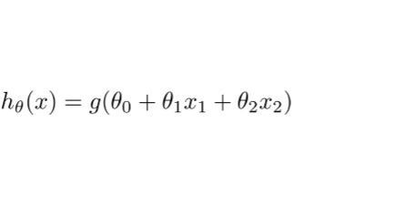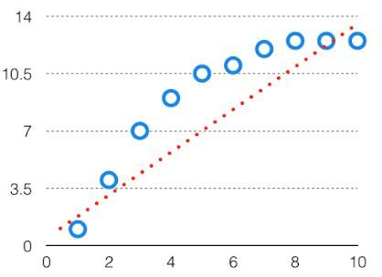

*HighBias*

In such a problem, a hypothesis looks like follows.  
  
**Variance**  
The variability of model prediction for a given data point which tells us spread of our data is called the variance of the model. The model with high variance has a very complex fit to the training data and thus is not able to fit accurately on the data which it hasn’t seen before. As a result, such models perform very well on training data but has high error rates on test data.  
When a model is high on variance, it is then said to as **Overfitting of Data**. Overfitting is fitting the training set accurately via complex curve and high order hypothesis but is not the solution as the error with unseen data is high.  
While training a data model variance should be kept low.

The high variance data looks like follows.

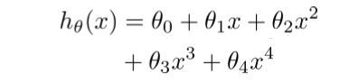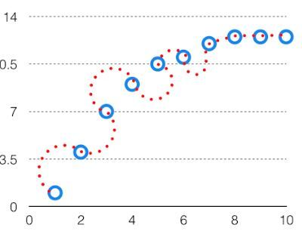

*High Variance*

In such a problem, a hypothesis looks like follows.  
  
**Bias Variance Tradeoff**

If the algorithm is too simple (hypothesis with linear eq.) then it may be on high bias and low variance condition and thus is error-prone. If algorithms fit too complex ( hypothesis with high degree eq.) then it may be on high variance and low bias. In the latter condition, the new entries will not perform well. Well, there is something between both of these conditions, known as Trade-off or Bias Variance Trade-off.

This tradeoff in complexity is why there is a tradeoff between bias and variance. An algorithm can’t be more complex and less complex at the same time. For the graph, the perfect tradeoff will be like.

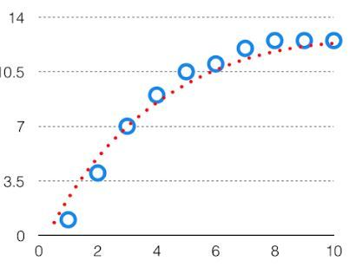  
The best fit will be given by hypothesis on the tradeoff point.

The error to complexity graph to show trade-off is given as –  
  
This is referred to as the best point chosen for the training of the algorithm which gives low error in training as well as testing data.

**Low-variance ML algorithms**: Linear Regression, Logistic Regression, Linear Discriminant Analysis.

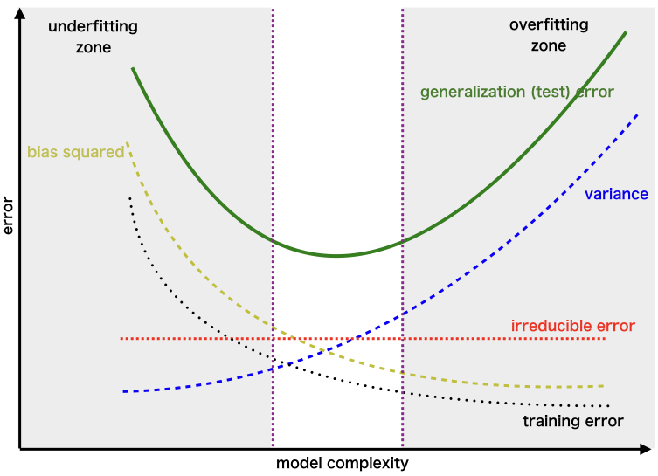**High-variance ML algorithms**: Decision Trees, k-NN, and Support Vector Machines.

BAGGING: Random Forest:

" The fundamental difference between bagging and random forest is that in Random forests, only a subset of features are selected at random out of the total and the best split feature from the subset is used to split each node in a tree, unlike in bagging where all features are considered for splitting a node."

Random Forest is one of the most popular and most powerful machine learning algorithms. It is a type of [ensemble machine learning algorithm](https://machinelearningmastery.com/ensemble-methods-for-deep-learning-neural-networks/) called Bootstrap Aggregation or bagging.

## Bootstrap Method

The bootstrap is a powerful statistical method for estimating a quantity from a data sample. This is easiest to understand if the quantity is a descriptive statistic such as a mean or a standard deviation.

Let’s assume we have a sample of 100 values (x) and we’d like to get an estimate of the mean of the sample.

We can calculate the mean directly from the sample as:

mean(x) = 1/100 * sum(x)

We know that our sample is small and that our mean has error in it. We can improve the estimate of our mean using the bootstrap procedure:

1. Create many (e.g. 1000) random sub-samples of our dataset with replacement (meaning we can select the same value multiple times).
2. Calculate the mean of each sub-sample.
3. Calculate the average of all of our collected means and use that as our estimated mean for the data.

This process can be used to estimate other quantities like the standard deviation and even quantities used in machine learning algorithms, like learned coefficients.

## Bootstrap Aggregation (Bagging)

Bootstrap Aggregation (or Bagging for short), is a simple and very powerful ensemble method.

An ensemble method is a technique that combines the predictions from multiple machine learning algorithms together to make more accurate predictions than any individual model.

Bootstrap Aggregation is a general procedure that can be used to reduce the variance for those algorithm that have high variance. An algorithm that has high variance are decision trees, like classification and regression trees (CART).

Decision trees are sensitive to the specific data on which they are trained. If the training data is changed (e.g. a tree is trained on a subset of the training data) the resulting decision tree can be quite different and in turn the predictions can be quite different.

Bagging is the application of the Bootstrap procedure to a high-variance machine learning algorithm, typically decision trees.

Let’s assume we have a sample dataset of 1000 instances (x) and we are using the CART algorithm. Bagging of the CART algorithm would work as follows.

1. Create many (e.g. 100) random sub-samples of our dataset with replacement.
2. Train a CART model on each sample.
3. Given a new dataset, calculate the average prediction from each model.

For example, if we had 5 bagged decision trees that made the following class predictions for a in input sample: blue, blue, red, blue and red, we would take the most frequent class and predict blue.

When bagging with decision trees, we are less concerned about individual trees overfitting the training data. For this reason and for efficiency, the individual decision trees are grown deep (e.g. few training samples at each leaf-node of the tree) and the trees are not pruned. These trees will have both high variance and low bias. These are important characteristics of sub-models when combining predictions using bagging.

The only parameters when bagging decision trees is the number of samples and hence the number of trees to include. This can be chosen by increasing the number of trees on run after run until the accuracy begins to stop showing improvement (e.g. on a cross validation test harness). Very large numbers of models may take a long time to prepare, but will not overfit the training data.

Just like the decision trees themselves, Bagging can be used for classification and regression problems.

## Random Forest

[Random Forests](https://machinelearningmastery.com/random-forest-ensemble-in-python/) are an improvement over bagged decision trees.

Suppose we have 1000 observations in the complete population with 10 variables. Random forest will try to build multiple CART along with different samples and different initial variables. It will take a random sample of 100 observations and then chose 5 initial variables randomly to build a CART model. It will go on repeating the process say about 10 times and then make a final prediction on each of the observations. Final prediction is a function of each prediction. This final prediction can simply be the mean of each prediction.

The random forest is a model made up of many decision trees. Rather than just simply averaging the prediction of trees (which we could call a “forest”), this model uses two key concepts that gives it the name *random*:

1. Random sampling of training data points when building trees
2. Random subsets of features considered when splitting nodes

A problem with decision trees like CART is that they are greedy. They choose which variable to split on using a greedy algorithm that minimizes error. As such, even with Bagging, the decision trees can have a lot of structural similarities and in turn have [high correlation](https://machinelearningmastery.com/how-to-use-correlation-to-understand-the-relationship-between-variables/) in their predictions.

Combining predictions from multiple models in ensembles works better if the predictions from the sub-models are uncorrelated or at best weakly correlated.

Random forest changes the algorithm for the way that the sub-trees are learned so that the resulting predictions from all of the subtrees have less correlation.

It is a simple tweak. In CART, when selecting a split point, the learning algorithm is allowed to look through all variables and all variable values in order to select the most optimal split-point. The random forest algorithm changes this procedure so that the learning algorithm is limited to a random sample of features of which to search.

The number of features that can be searched at each split point (m) must be specified as a parameter to the algorithm. You can try different values and tune it using cross validation.

* For classification a good default is: m = sqrt(p)
* For regression a good default is: m = p/3

Where m is the number of randomly selected features that can be searched at a split point and p is the number of input variables. For example, if a dataset had 25 input variables for a classification problem, then:

* m = sqrt(25)
* m = 5

## Estimated Performance

For each bootstrap sample taken from the training data, there will be samples left behind that were not included. These samples are called Out-Of-Bag samples or OOB.

The performance of each model on its left out samples when averaged can provide an estimated accuracy of the bagged models. This estimated performance is often called the OOB estimate of performance.

These performance measures are reliable test error estimate and correlate well with cross validation estimates.

## Variable Importance

As the Bagged decision trees are constructed, we can calculate how much the error function drops for a variable at each split point.

In regression problems this may be the drop in sum squared error and in classification this might be the Gini score.

These drops in error can be averaged across all decision trees and output to provide an estimate of the importance of each input variable. The greater the drop when the variable was chosen, the greater the importance.

These outputs can help identify subsets of input variables that may be most or least relevant to the problem and suggest at possible feature selection experiments you could perform where some features are removed from the dataset.

### Why a Forest is better than One Tree?

The main objective of a machine learning model is to generalize properly to new and unseen data. When we have a flexible model, **overfitting** takes place. A flexible model is said to have high **variance**because the learned parameters (such as the structure of the decision tree) will vary with the training data.

On the other hand, an inflexible model is said to have high **bias** as it makes **assumptions** about the training data. An inflexible model may not have the capacity to fit even the training data and in both cases — high variance and high bias — the model is not able to generalize new and unseen data properly.

You can through the article on one of the foundational concepts in machine learning, [bias-variance tradeoff](https://www.knowledgehut.com/blog/data-science/bias-variance-tradeoff-in-machine-learning) which will help you understand that the balance between creating a model that is so flexible memorizes the training data and an inflexible model cannot learn the training data.

The main reason why decision tree is prone to overfitting when we do not limit the maximum depth is because it has unlimited flexibility, which means it keeps growing unless there is one leaf node for every single observation.

Instead of limiting the depth of the tree which results in reduced variance and increase in bias, we can combine many decision trees into a single ensemble model known as the **random forest**.

Ensemble methods aim at improving the predictive performance of a given statistical learning or model ﬁtting technique. The general principle of ensemble methods is to construct a linear combination of some model ﬁtting method, instead of using a single ﬁt of the method.

An ensemble is itself a supervised learning algorithm, because it can be trained and then used to make predictions. Ensemble methods combine several decision trees classifiers to produce better predictive performance than a single decision tree classifier. The main principle behind the ensemble model is that a group of weak learners come together to form a strong learner, thus increasing the accuracy of the model.When we try to predict the target variable using any machine learning technique, the main causes of difference in actual and predicted values are **noise, variance, and bias**. Ensemble helps to reduce these factors (except noise, which is irreducible error). The noise-related error is mainly due to noise in the training data and can't be removed. However, the errors due to bias and variance can be reduced.  
The total error can be expressed as follows:

**Total Error = Bias + Variance + Irreducible Error**

A measure such as **mean square error** (**MSE**) captures all of these errors for a continuous target variable and can be represented as follows:

Where, E stands for the expected mean, Y represents the actual target values and fˆ(x) is the predicted values for the target variable. It can be broken down into its components such as bias, variance and noise as shown in the following formula:

Using techniques like Bagging and Boosting helps to decrease the variance and increase the robustness of the model. Combinations of multiple classifiers decrease variance, especially in the case of unstable classifiers, and may produce a more reliable classification than a single classifier.

### Ensemble Algorithm

The goal of ensemble algorithms is to combine the predictions of several base estimators built with a given learning algorithm in order to improve generalizability / robustness over a single estimator.

There are two families of ensemble methods which are usually distinguished:

1. **Averaging methods.**The driving principle is to build several estimators independently and then to average their predictions. On average, the combined estimator is usually better than any of the single base estimator because its variance is reduced.|  
   **Examples:** Bagging methods, Forests of randomized trees.
2. **Boosting methods.**Base estimators are built sequentially and one tries to reduce the bias of the combined estimator. The motivation is to combine several weak models to produce a powerful ensemble.  
   **Examples:** AdaBoost, Gradient Tree Boosting.

### Advantages of Ensemble Algorithm

* Ensemble is a proven method for improving the accuracy of the model and works in most of the cases.
* Ensemble makes the model more robust and stable thus ensuring decent performance on the test cases in most scenarios.
* You can use ensemble to capture linear and simple as well nonlinear complex relationships in the data. This can be done by using two different models and forming an ensemble of two.

### Disadvantages of Ensemble Algorithm

* Ensemble reduces the model interpret-ability and makes it very difficult to draw any crucial business insights at the end
* It is time-consuming and thus might not be the best idea for real-time applications
* The selection of models for creating an ensemble is an art which is really hard to master

## Basic Ensemble Techniques

* **Max Voting:** Max-voting is one of the simplest ways of combining predictions from multiple machine learning algorithms. Each base model makes a prediction and votes for each sample. The sample class with the highest votes is considered in the final predictive class. It is mainly used for classification problems.
* **Averaging:** Averaging can be used while estimating the probabilities in classification tasks. But it is usually used for regression problems. Predictions are extracted from multiple models and an average of the predictions are used to make the final prediction.
* **Weighted Average:** Like averaging, weighted averaging is also used for regression tasks. Alternatively, it can be used while estimating probabilities in classification problems. Base learners are assigned different weights, which represent the importance of each model in the prediction.

## Ensemble Methods

Ensemble methods became popular as a relatively simple device to improve the predictive performance of a base procedure. There are diﬀerent reasons for this: the bagging procedure turns out to be a variance reduction scheme, at least for some base procedures. On the other hand, boosting methods are primarily reducing the (model) bias of the base procedure. This already indicates that bagging and boosting are very diﬀerent ensemble methods. From the perspective of prediction, random forests is about as good as boosting, and often better than bagging.

**B**ootstrap **Agg**regation or **Bagging** tries to implement similar learners on small sample populations and then takes a mean of all the predictions.

* It combines Bootstrapping and Aggregation to form one ensemble model
* Reduces the variance error and helps to avoid overfitting

Bagging algorithms include:

* Bagging meta-estimator
* Random forest

**Boosting** refers to a family of algorithms which converts weak learner to strong learners. Boosting is a sequential process, where each subsequent model attempts to correct the errors of the previous model. Boosting is focused on reducing the bias. It makes the boosting algorithms prone to overfitting. To avoid overfitting, parameter tuning plays an important role in boosting algorithms. Some examples of boosting are mentioned below:

* AdaBoost
* GBM
* XGBM
* Light GBM
* CatBoost

## Why use ensemble models?

Ensemble models help in improving algorithm accuracy as well as the robustness of a model. Both Bagging and Boosting should be known by data scientists and machine learning engineers and especially people who are planning to attend data science/machine learning interviews.

Ensemble learning uses hundreds to thousands of models of the same algorithm and then work hand in hand to find the correct classification. You may also consider the [fable of the blind men and the elephant](https://en.wikipedia.org/wiki/Blind_men_and_an_elephant) to understand ensemble learning, where each blind man found a feature of the elephant and they all thought it was something different. However, if they would work together and discussed among themselves, they might have figured out what it is.

Using techniques like bagging and boosting leads to increased robustness of statistical models and decreased variance. Now the question becomes, between these different “B” words. Which is better?

## **Which is better, Bagging or Boosting?**

There is no perfectly correct answer to that. It depends on the data, the simulation and the circumstances.

Bagging and Boosting decrease the variance of your single estimate as they combine several estimates from different models. So the result may be a model with **higher stability**.

If the problem is that the single model gets a very low performance, Bagging will rarely get a **better bias**. However, Boosting could generate a combined model with lower errors as it optimizes the advantages and reduces pitfalls of the single model.

By contrast, if the difficulty of the single model is **overfitting**, then Bagging is the best option. Boosting for its part doesn’t help to avoid over-fitting; in fact, this technique is faced with this problem itself. For this reason, Bagging is effective more often than Boosting. In this article we will discuss about Bagging, we will cover Boosting in the next post. But first, let us look into the very important concept of bootstrapping.

### Bootstrap Sampling

Sampling is the process of selecting a subset of observations from the population with the purpose of estimating some parameters about the whole population. Resampling methods, on the other hand, are used to improve the estimates of the population parameters.

In machine learning, the bootstrap method refers to random sampling with replacement. This sample is referred to as a resample. This allows the model or algorithm to get a better understanding of the various biases, variances and features that exist in the resample. Taking a sample of the data allows the resample to contain different characteristics then it might have contained as a whole. This is demonstrated in figure 1 where each sample population has different pieces, and none are identical. This would then affect the overall mean, standard deviation and other descriptive metrics of a data set. In turn, it can develop more robust models.

Bootstrapping is also great for small size data sets that can have a tendency to overfit. In fact, we recommended this to one company who was concerned because their data sets were far from “Big Data”. Bootstrapping can be a solution in this case because algorithms that utilize bootstrapping can be more robust and handle new data sets depending on the methodology chosen(boosting or bagging).

The reason behind using the bootstrap method is because it can test the stability of a solution. By using multiple sample data sets and then testing multiple models, it can increase robustness. Perhaps one sample data set has a larger mean than another, or a different standard deviation. This might break a model that was overfit, and not tested using data sets with different variations.

One of the many reasons bootstrapping has become very common is because of the increase in computing power. This allows for many times more permutations to be done with different resamples than previously. Bootstrapping is used in both Bagging and Boosting

Let us assume we have a sample of ‘n’ values (x) and we’d like to get an estimate of the mean of the sample.

mean(x) = 1/n * sum(x)

Consider a sample of 100 values (x) and we’d like to get an estimate of the mean of the sample. We can calculate the mean directly from the sample as:

We know that our sample is small and that the mean has an error in it. We can improve the estimate of our mean using the bootstrap procedure:

1. Create many (e.g. 1000) random sub-samples of the data set with replacement (meaning we can select the same value multiple times).
2. Calculate the mean of each sub-sample
3. Calculate the average of all of our collected means and use that as our estimated mean for the data

E**xample:** Suppose we used 3 re-samples and got the mean values 2.3, 4.5 and 3.3. Taking the average of these we could take the estimated mean of the data to be 3.367. This process can be used to estimate other quantities like the standard deviation and even quantities used in machine learning algorithms, like learned coefficients.

While using Python, we do not have to implement the bootstrap method manually. The scikit-learn library provides an implementation that creates a single bootstrap sample of a dataset.

The [resample() scikit-learn function](https://scikit-learn.org/stable/modules/generated/sklearn.utils.resample.html) can be used for sampling. It takes as arguments the data array, whether or not to sample with replacement, the size of the sample, and the seed for the pseudorandom number generator used prior to the sampling.

### Bagging

**Bootstrap Aggregation**, also known as **Bagging**, is a powerful ensemble method that was proposed by Leo Breiman in 1994 to prevent overfitting. The concept behind bagging is to combine the predictions of several base learners to create a more accurate output. Bagging is the application of the Bootstrap procedure to a high-variance machine learning algorithm, typically decision trees.

1. Suppose there are N observations and M features. A sample from observation is selected randomly with replacement (Bootstrapping).
2. A subset of features are selected to create a model with sample of observations and subset of features.
3. Feature from the subset is selected which gives the best split on the training data.
4. This is repeated to create many models and every model is trained in parallel
5. Prediction is given based on the aggregation of predictions from all the models.

This approach can be used with machine learning algorithms that have a high variance, such as decision trees. A separate model is trained on each bootstrap sample of data and the average output of those models used to make predictions. This technique is called bootstrap aggregation or bagging for short.

Variance means that an algorithm’s performance is sensitive to the training data, with high variance suggesting that the more the training data is changed, the more the performance of the algorithm will vary.

The performance of high variance machine learning algorithms like unpruned decision trees can be improved by training many trees and taking the average of their predictions. Results are often better than a single decision tree.

What Bagging does is help reduce variance from models that are might be very accurate, but only on the data they were trained on. This is also known as overfitting.

Overfitting is when a function fits the data too well. Typically this is because the actual equation is much too complicated to take into account each data point and outlier.

Bagging gets around this by creating its own variance amongst the data by sampling and replacing data while it tests multiple hypothesis(models). In turn, this reduces the noise by utilizing multiple samples that would most likely be made up of data with various attributes(median, average, etc).

Once each model has developed a hypothesis. The models use voting for classification or averaging for regression. This is where the “Aggregating” in “Bootstrap Aggregating” comes into play. Each hypothesis has the same weight as all the others. When we later discuss boosting, this is one of the places the two methodologies differ.

Essentially, all these models run at the same time, and vote on which hypothesis is the most accurate.

This helps to decrease variance i.e. reduce the overfit.

### Advantages

* Bagging takes advantage of ensemble learning wherein multiple weak learners outperform a single strong learner.
* It helps reduce variance and thus helps us avoid overfitting.

### Disadvantages

* There is loss of interpretability of the model.
* There can possibly be a problem of high bias if not modeled properly.
* While bagging gives us more accuracy, it is computationally expensive and may not be desirable depending on the use case.

There are many bagging algorithms of which perhaps the most prominent would be Random Forest.

Boosting: Adaboost

**Boosting** is an ensemble modeling technique that attempts to build a strong classifier from the number of weak classifiers. It is done by building a model by using weak models in series. Firstly, a model is built from the training data. Then the second model is built which tries to correct the errors present in the first model. This procedure is continued and models are added until either the complete training data set is predicted correctly or the maximum number of models are added.

**AdaBoost** was the first really successful boosting algorithm developed for the purpose of binary classification. *AdaBoost* is short for *Adaptive Boosting* and is a very popular boosting technique that combines multiple “weak classifiers” into a single “strong classifier”. It was formulated by Yoav Freund and Robert Schapire. They also won the 2003 Gödel Prize for their work.

**Algorithm:** 

1. *Initialise the dataset and assign equal weight to each of the data point.*
2. *Provide this as input to the model and identify the wrongly classified data points.*
3. *Increase the weight of the wrongly classified data points.*
4. *if (got required results)   
     Goto step 5   
   else   
     Goto step 2*
5. *End*

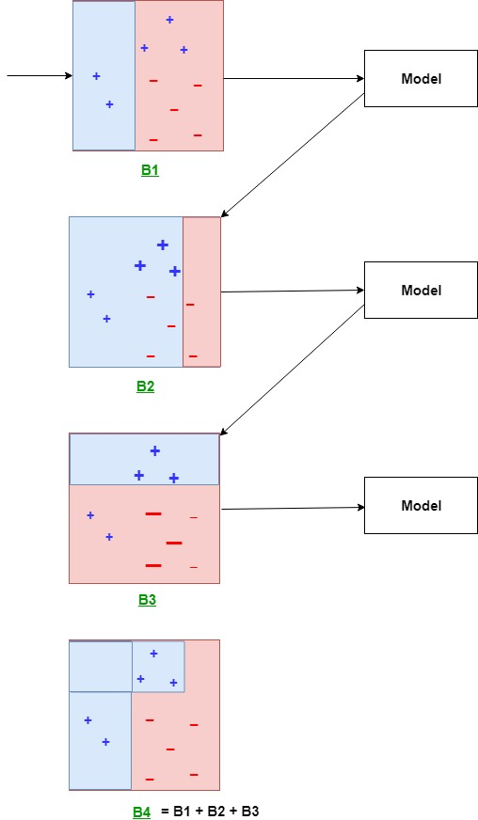

**Explanation:**   
The above diagram explains the AdaBoost algorithm in a very simple way. Let’s try to understand it in a stepwise process:

* **B1** consists of 10 data points which consist of two types namely plus(+) and minus(-) and 5 of which are plus(+) and the other 5 are minus(-) and each one has been assigned equal weight initially. The first model tries to classify the data points and generates a vertical separator line but it wrongly classifies 3 plus(+) as minus(-).
* **B2** consists of the 10 data points from the previous model in which the 3 wrongly classified plus(+) are weighted more so that the current model tries more to classify these pluses(+) correctly. This model generates a vertical separator line that correctly classifies the previously wrongly classified pluses(+) but in this attempt, it wrongly classifies two minuses(-).
* **B3** consists of the 10 data points from the previous model in which the 3 wrongly classified minus(-) are weighted more so that the current model tries more to classify these minuses(-) correctly. This model generates a horizontal separator line that correctly classifies the previously wrongly classified minuses(-).
* **B4** combines together B1, B2, and B3 in order to build a strong prediction model which is much better than any individual model used.

**BOOSTING**

a. Concept

The intuition described above can be described as such :

* Train the model h1 on the whole set
* Train the model h2 with exaggerated data on the regions in which h1 performs poorly
* Train the model h3 with exaggerated data on the regions in which h1 ≠ h2

Instead of training the models in **parallel**, we can train them **sequentially**. This is the essence of Boosting !

Boosting trains a series a low performing algorithms, called weak learners, by adjusting the error metric over time. Weak learners are algorithms whose error rate is slightly under 50% as illustrated below :

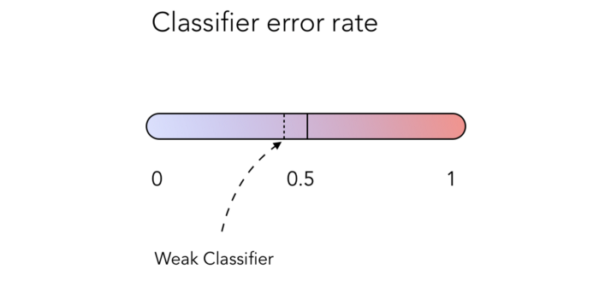

A weak classifier, achieving just under 50% error rate

b. Weighted errors

How could we implement such classifier ? By weighting errors throughout the iterations ! This would give more weight to regions in which the previous classifiers performed poorly.

Let’s consider data points on a 2D plot. Some of them will be well classified, others won’t. Usually, the weight attributed to each error when computing the error rate is 1/n where n is the number of data points to classify.

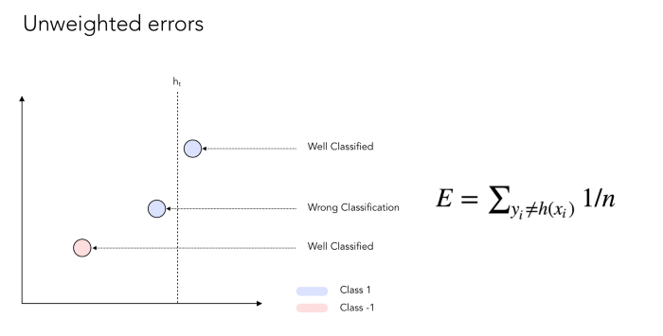

Unweighted Errors

Now if we apply some weight to the errors :

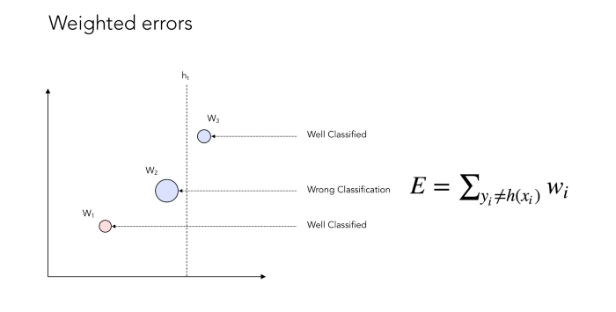

Weighted Errors

You might now notice that we give more weight to the data points that are not well classified. Here’s an illustration of the weighting process :

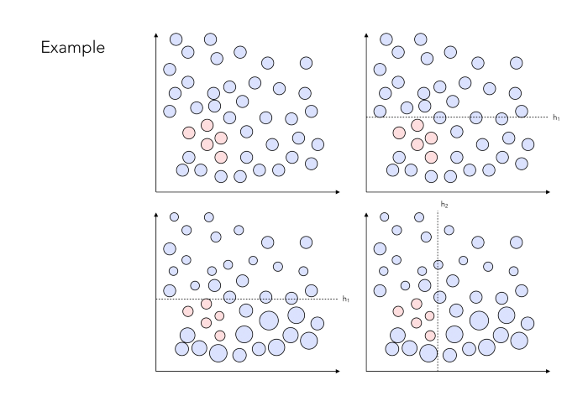

Example of weighting process

In the end, we want to build a strong classifier that may look like this :

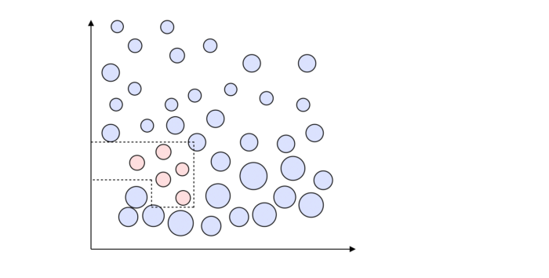

Strong Classifier

c. Tree stumps

One question you might ask, is how many classifiers should one implement in order to have it working well ? And how is each classifier chosen at each step ?

The answer lies in the definition of so-called tree stumps ! Tree stumps defines a 1-level decision tree. The main idea is that at each step, we want to find the best stump, i.e the best data split, that minimizes the overall error. You can see a stump as a test, in which the assumption is that everything that lies on one side belongs to class 1, and everything that lies on the other side belongs to class 0.

There are a lot of combinations possible for a tree stump. Let’s see how many combinations we face in our simple example ? Let’s take a minute to count them.

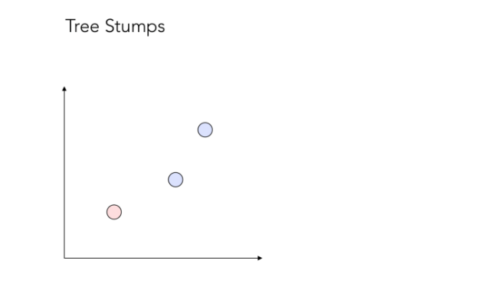

3 data points to split

Well, the answer is… 12 ! It might seem surprising, but it’s rather easy to understand.

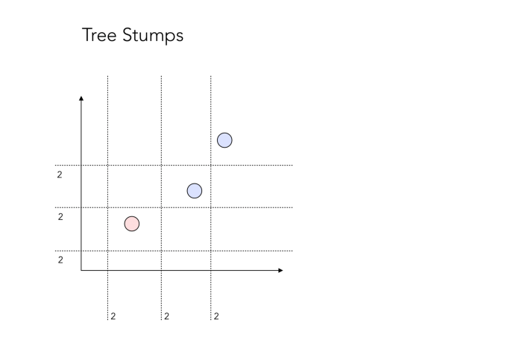

12 Stumps

There are 12 possible “test” we could make. The “2” on the side of each separating line simply represents the fact that all points on one side could be points that belong to class 0, or to class 1. Therefore, there’s 2 tests embedded in it.

At each iteration t, we will choose ht the weak classifier that splits best the data, by reducing the overall error rate the most. Recall that the error rate is a modified error rate version that takes into account what has been introduced before.

d. Finding the best split

As stated above, the best split is found by identifying at each iteration t, the best weak classifier ht, generally a decision tree with 1 node and 2 leaves (a stump). Suppose that we are trying a predict whether someone who wants to borrow money will be a good payer or not :

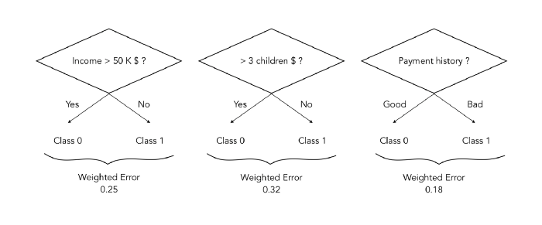

Identifying the best split

In this case, the best split at time t is to stump on the Payment history, since the weighted error resulting of this split is minimal.

Simply note that decision tree classifiers like these ones can in practice be deeper than a simple stump. This will be a hyper-parameter.

e. Combining classifiers

The next logical step is to combine the classifiers into a Sign classifier, and depending on which side of the frontier a point will stand, it will be classified as 0 or 1. It can be achieved this way :

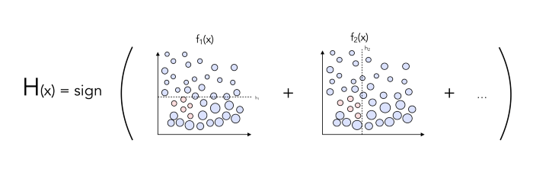

Combining classifiers

Do you see any way to potentially improve the classifier ?

By adding weights on each classifier, to avoid giving the same importance to the different classifiers.

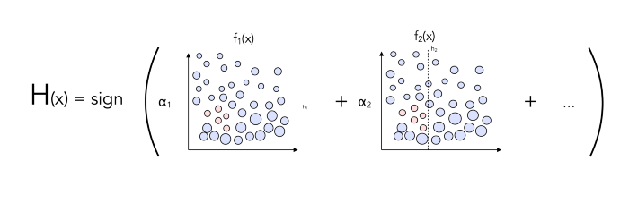

AdaBoost

f. Wrapping it up

Let’s wrap up in a small pseudo-code what we covered so far.

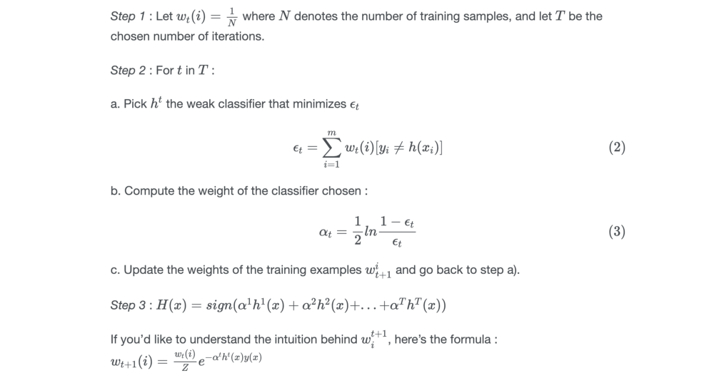

Pseudo-Code

The key elements to remember from it are :

* Z is a constant whose role is to normalize the weights so that they add up to 1 !
* αt is a weight that we apply to each classifier

And we’re done ! This algorithm is called **AdaBoost**. This is the most important algorithm one needs to understand in order to fully understand all boosting methods.

III. Computation

Boosting algorithms are rather fast to train, which is great. But how come they’re fast to train since we consider every stump possible and compute exponentials recursively ?

Well, here’s where the magic happens. If we choose properly αt and Z, the weights that are supposed to change at each step simplify to :

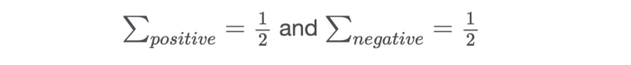

Weights after choice of α and Z

This is a very strong result, and it does not contradict the statement according to which the weights should vary with the iterations, since the number of training samples that are badly classified drops, and their total weights is still 0.5 !

* No Z to compute
* No α
* No exponential

And there’s another trick : any classifier that tries to split 2 well classified data points will never be optimal. There’s no need to even compute it.

STACKING:

While bagging and boosting used homogenous weak learners for ensemble, Stacking often considers heterogeneous weak learners, learns them in parallel, and combines them by training a meta-learner to output a prediction based on the different weak learner’s predictions. A meta learner inputs the predictions as the features and the target being the ground truth values in data D(Fig 2.), it attempts to learn how to best combine the input predictions to make a better output prediction.

In averaging ensemble eg. Random Forest, the model combines the predictions from multiple trained models. A limitation of this approach is that each model contributes the same amount to the ensemble prediction, irrespective of how well the model performed. An alternate approach is a weighted average ensemble, which weighs the contribution of each ensemble member by the trust on their contribution in giving the best predictions. The weighted average ensemble provides an improvement over the model average ensemble.

A further generalization of this approach is replacing the linear weighted sum with Linear Regression (regression problem) or Logistic Regression (classification problem) to combine the predictions of the sub-models with any learning algorithm. This approach is called **Stacking**.

In stacking, an algorithm takes the outputs of sub-models as input and attempts to learn how to best combine the input predictions to make a better output prediction.

Enough of the theory. Let’s see the hands-on part!

### **Stacking for Machine Learning**

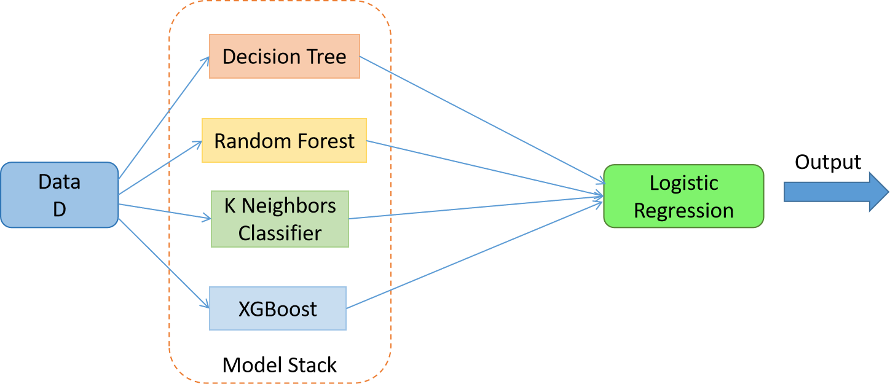Fig 3. The stacked model with meta learner = Logistic Regression and the weak learners = Decision Tree, Random Forest, K Neighbors Classifier and XGBoost

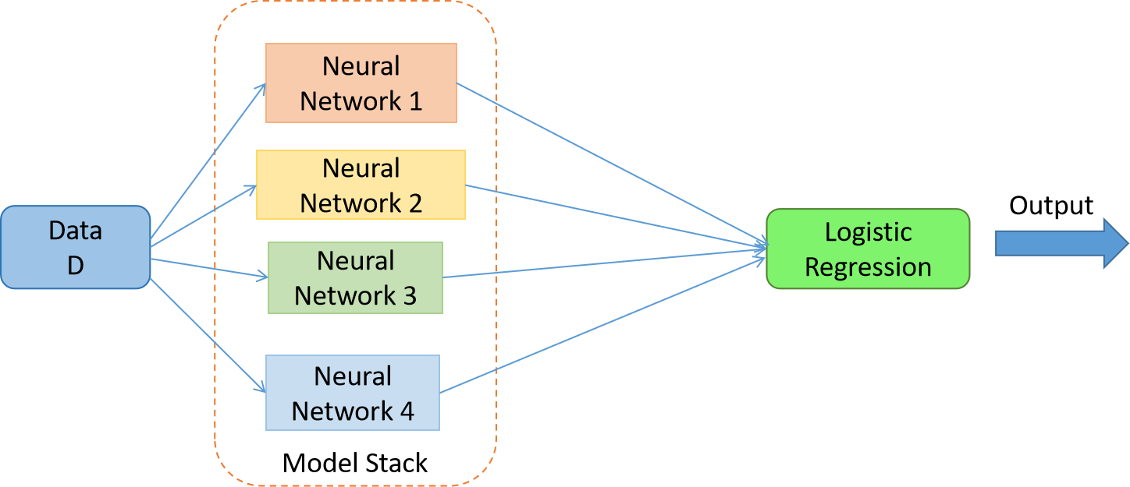Fig 4. The stacked model with meta learner = Logistic Regression and weak learners = 4 Neural Networks

With this, we can conclude that the stacked model can give better performance than the individual models. No doubt why Stacking Ensembling is the favorite approach to win hackathons and give state-of-the-art results.

**How stacking works?**

1. We split the training data into K-folds just like K-fold cross-validation.
2. A base model is fitted on the K-1 parts and predictions are made for Kth part.
3. We do for each part of the training data.
4. The base model is then fitted on the whole train data set to calculate its performance on the test set.
5. We repeat the last 3 steps for other base models.
6. Predictions from the train set are used as features for the second level model.
7. Second level model is used to make a prediction on the test set.

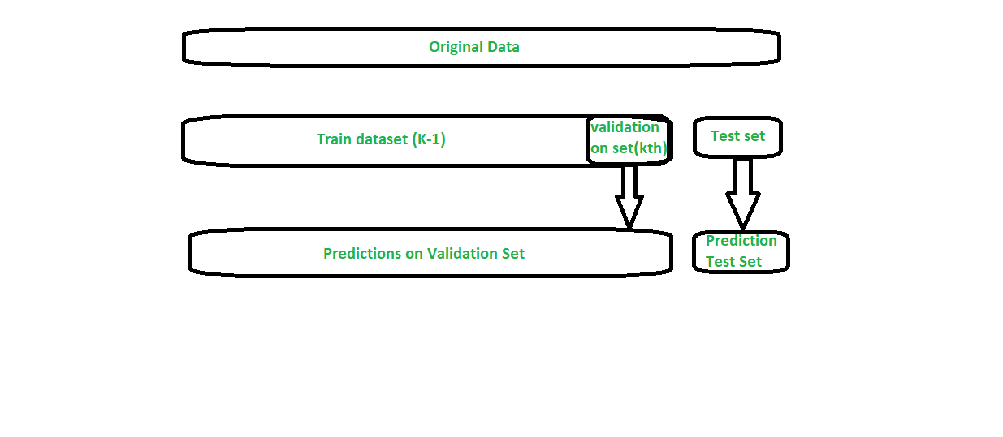

### Blending –

Blending is a similar approach to stacking.

* The train set is split into training and validation sets.
* We train the base models on the training set.
* We make predictions only on the validation set and the test set.
* The validation predictions are used as features to build a new model.
* This model is used to make final predictions on the test set using the prediction values as features.
* Stacking is a way to ensemble multiple classifications or regression model. There are many ways to ensemble models, the widely known models are ***Bagging***or ***Boosting***. Bagging allows multiple similar models with high variance are averaged to decrease variance. Boosting builds multiple incremental models to decrease the bias, while keeping variance small.
* Stacking (sometimes called *Stacked Generalization*) is a different paradigm. The point of stacking is to explore a space of different models for the same problem. The idea is that you can attack a learning problem with different types of models which are capable to learn some part of the problem, but not the whole space of the problem. So, you can build multiple different learners and you use them to build an intermediate prediction, one prediction for each learned model. Then you add a new model which learns from the intermediate predictions the same target.  
  This final model is said to be stacked on the top of the others, hence the name. Thus, you might improve your overall performance, and often you end up with a model which is better than any individual intermediate model. Notice however, that it does not give you any guarantee, as is often the case with any machine learning technique.  
  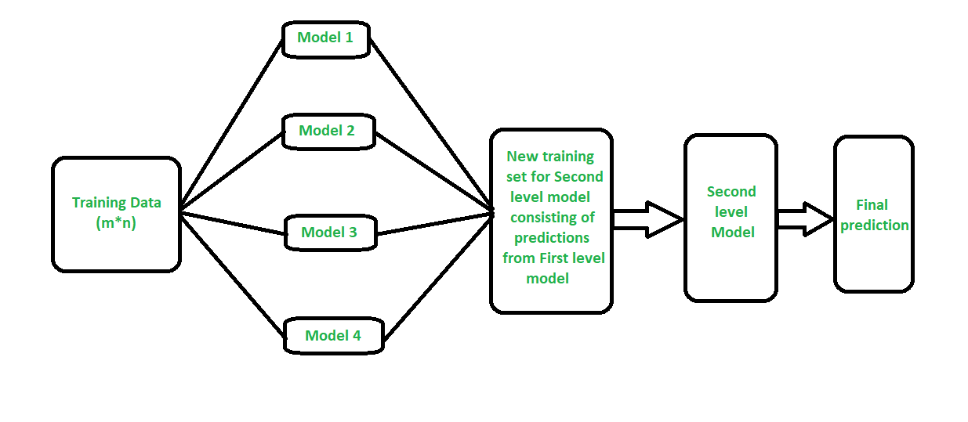

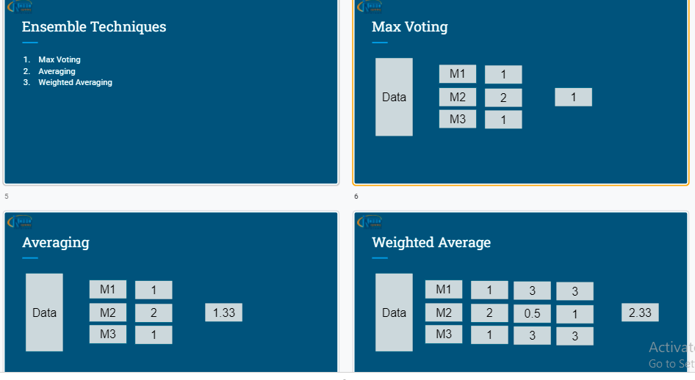

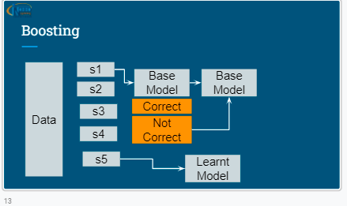

**Probabilistic Learning**

**It is accounting for uncertainty both model uncertainty and data uncertainty. It uses probabilistic models and Deep neural networks.**

## Graphical user interface, application, treemap chart Description automatically generatedWhat is Bayesian machine learning?

Bayesian ML is a paradigm for constructing statistical models based on Bayes’ Theorem

p(θ|x)=p(x|θ)p(θ)p(x)

Generally speaking, the goal of Bayesian ML is to estimate the posterior distribution (p(θ|x)p(θ|x)) given the likelihood (p(x|θ)p(x|θ)) and the prior distribution, p(θ)p(θ). The likelihood is something that can be estimated from the training data.

In fact, that’s exactly what we’re doing when training a regular machine learning model. We’re performing Maximum Likelihood Estimation, an iterative process which updates the model’s parameters in an attempt to maximize the probability of seeing the training data xx having already seen the model parameters θθ.

So how does the Bayesian paradigm differ? Well, things get turned on their head in that in this instance we actually seek to maximize the posterior distribution which takes the training data as fixed and determines the probability of any parameter setting θθ given that data. We call this process *Maximum a Posteriori (MAP)*. It’s easier, however, to think about it in terms of the likelihood function. By Bayes’ Theorem we can write the posterior as

p(θ|x)∝p(x|θ)p(θ)

Here we leave out the denominator, p(x)p(x), because we are taking the maximization with respect to θθ which p(x)p(x) does not depend on. Therefore, we can ignore it in the maximization procedure. The key piece of the puzzle which leads Bayesian models to differ from their classical counterparts trained by MLE is the inclusion of the term p(θ)p(θ). We call this the *prior distribution*over θθ.

The idea is that its purpose is to encode our beliefs about the model’s parameters before we’ve even seen them. That’s to say, we can often make reasonable assumptions about the “suitability” of different parameter configurations based simply on what we know about the problem domain and the laws of statistics. For example, it’s pretty common to use a Gaussian prior over the model’s parameters. This means we assume that they’re drawn from a normal distribution having some mean and variance. This distribution’s classic bell-curved shape consolidates most of its mass close to the mean while values towards its tails are rather rare.

By using such a prior, we’re effectively stating a belief that most of the model’s weights will fall in some narrow range about a mean value with the exception of a few outliers, and this is pretty reasonable given what we know about most real world phenomena.

It turns out that using these prior distributions and performing MAP is equivalent to performing MLE in the classical sense *along with the addition of regularization*. There’s a pretty easy mathematical proof of this fact that we won’t go into here, but the gist is that by constraining the acceptable model weights via the prior we’re effectively imposing a regularizer.

## Methods of Bayesian ML

### MAP

While MAP is the first step towards fully Bayesian machine learning, it’s still only computing what statisticians call a *point estimate*, that is the estimate for the value of a parameter at a single point, calculated from data. The downside of point estimates is that they don’t tell you much about a parameter other than its optimal setting. In reality, we often want to know other information, like how certain we are that a parameter’s value should fall within this predefined range.

To that end, the true power of Bayesian ML lies in the computation of the entire posterior distribution. This is a tricky business though. Distributions are not nicely packaged mathematical objects that can be manipulated at will. Often they come defined to us as tricky, intractable integrals over continuous parameter spaces that are infeasible to analytically compute. Therefore, a number of fascinating Bayesian methods have been devised that can be used to *sample*(i.e. draw sample values) from the posterior distribution.

### MCMC

Probably the most famous of these is an algorithm called *Markov Chain Monte Carlo*, an umbrella which contains a number of subsidiary methods such as *Gibbs*and *Slice Sampling.* The math behind MCMC is difficult but intriguing. In essence, these methods work by constructing a known Markov chain which settles into a distribution that’s equivalent to the posterior. A number of successor algorithms improve on the MCMC methodology by using gradient information to allow the sampler to more efficiently navigate the parameter space.

MCMC and its relatives are often used as a computational cog in a broader Bayesian model. Their downside is that they are often very computationally inefficient, although this drawback has been improved tremendously in recent years. That said, it’s often preferable to use the simplest tool possible for any given job.

To that end, there exist many simpler methods which can often get the job done. For example, there exist Bayesian linear and logistic regression equivalents in which something called the *Laplace Approximation* is used. This algorithm provides an analytical approximation to the posterior distribution by computing a second-order Taylor expansion around the log-posterior and centered at the MAP estimate.

### Gaussian process

One popular Bayesian method capable of performing both classification and regression is the *Gaussian process*. A GP is a stochastic process with strict Gaussian conditions imposed upon its constituent random variables. GPs have a rather profound theoretical underpinning, and much effort has been devoted to their study. In effect, these processes provide the ability to perform regression in function space.

That is, instead of choosing a single line to best fit your data, you can determine a probability distribution over the *space of all possible lines* and then select the line that is most likely given the data as the actual predictor. This is Bayesian estimation in the truest sense in that the full posterior distribution is analytically computed. The ability to actually work out the method in this instance is due to the suitability of *conjugate functions*.

In the case of classification using GPs, the posterior is once again no longer conjugate to the likelihood, and the ability to do analytic computations breaks down. In this case, it’s necessary to once again resort to approximate solvers like the Laplace Approximation in order to suitably train the model to a desired level of accuracy.

## The presence of Bayesian models in ML

While Bayesian models are not nearly as widespread in industry as their counterparts, they are beginning to experience a new resurgence due to the recent development of computationally tractable sampling algorithms, greater access to CPU/GPU processing power, and their dissemination in arenas outside academia.

They are especially useful in low-data domains where deep learning methods often fail and in regimes in which the ability to reason about a model is essential. In particular, they see wide use in Bioinformatics and Healthcare, as in these fields taking a point estimate at face value can often have catastrophic effects and more insight into the underlying model is necessary.

For example, one would not want to naively trust the outputs of an MRI cancer prediction model without at least first having some knowledge about how that model was operating. Similarly, within bioinformatics, variant callers such as Mutect2 and Strelka rely heavily on Bayesian methods underneath the hood.

These software programs take in DNA reads from a person’s genome and label “variant” alleles which differ from those in the reference. In this domain, accuracy and statistical soundness are paramount, so Bayesian methods make a lot of sense despite the complexity that they add in implementation.

Overall, Bayesian ML is a fast growing subfield of machine learning and looks to develop even more rapidly in the coming years as advancements in computer hardware and statistical methodologies continue to make their way into the established canon.

## Bayes Optimal Classifier

The Bayes optimal classifier is a probabilistic model that makes the most probable prediction for a new example, given the training dataset.

This model is also referred to as the Bayes optimal learner, the Bayes classifier, Bayes optimal decision boundary, or the Bayes optimal discriminant function.

* **Bayes Classifier**: Probabilistic model that makes the most probable prediction for new examples.

Specifically, the Bayes optimal classifier answers the question:

***What is the most probable classification of the new instance given the training data?***

This is different from the MAP framework that seeks the most probable hypothesis (model). Instead, we are interested in making a specific prediction.

*In general, the most probable classification of the new instance is obtained by combining the predictions of all hypotheses, weighted by their posterior probabilities.*

— Page 175, [Machine Learning](https://amzn.to/2O1R51L), 1997.

The equation below demonstrates how to calculate the conditional probability for a new instance (vi) given the training data (D), given a space of hypotheses (H).

* P(vj | D) = sum {h in H} P(vj | hi) * P(hi | D)

Where vj is a new instance to be classified, H is the set of hypotheses for classifying the instance, hi is a given hypothesis, P(vj | hi) is the posterior probability for vi given hypothesis hi, and P(hi | D) is the posterior probability of the hypothesis hi given the data D.

Selecting the outcome with the maximum probability is an example of a Bayes optimal classification.

* max sum {h in H} P(vj | hi) * P(hi | D)

Any model that classifies examples using this equation is a Bayes optimal classifier and no other model can outperform this technique, on average.

*Any system that classifies new instances according to [the equation] is called a Bayes optimal classifier, or Bayes optimal learner. No other classification method using the same hypothesis space and same prior knowledge can outperform this method on average.*

— Page 175, [Machine Learning](https://amzn.to/2O1R51L), 1997.

We have to let that sink in.

It is a big deal.

It means that any other algorithm that operates on the same data, the same set of hypotheses, and same prior probabilities cannot outperform this approach, on average. Hence the name “optimal classifier.”

Although the classifier makes optimal predictions, it is not perfect given the uncertainty in the training data and incomplete coverage of the problem domain and hypothesis space. As such, the model will make errors. These errors are often referred to as Bayes errors.

*The Bayes classifier produces the lowest possible test error rate, called the Bayes error rate. […] The Bayes error rate is analogous to the irreducible error …*

— Page 38, [An Introduction to Statistical Learning with Applications in R](https://amzn.to/2O4gCHv), 2017.

Because the Bayes classifier is optimal, the Bayes error is the minimum possible error that can be made.

* **Bayes Error**: The minimum possible error that can be made when making predictions.

Further, the model is often described in terms of classification, e.g. the Bayes Classifier. Nevertheless, the principle applies just as well to regression: that is, predictive modeling problems where a numerical value is predicted instead of a class label.

It is a theoretical model, but it is held up as an ideal that we may wish to pursue.

*In theory we would always like to predict qualitative responses using the Bayes classifier. But for real data, we do not know the conditional distribution of Y given X, and so computing the Bayes classifier is impossible. Therefore, the Bayes classifier serves as an unattainable gold standard against which to compare other methods.*

— Page 39, [An Introduction to Statistical Learning with Applications in R](https://amzn.to/2O4gCHv), 2017.

Because of the computational cost of this optimal strategy, we instead can work with direct simplifications of the approach.

Two of the most commonly used simplifications use a sampling algorithm for hypotheses, such as Gibbs sampling, or to use the simplifying assumptions of the Naive Bayes classifier.

* **Gibbs Algorithm**. Randomly sample hypotheses biased on their posterior probability.
* **Naive Bayes**. Assume that variables in the input data are conditionally independent.

For more on the topic of Naive Bayes, see the post:

* [How to Develop a Naive Bayes Classifier from Scratch in Python](https://machinelearningmastery.com/classification-as-conditional-probability-and-the-naive-bayes-algorithm)

Nevertheless, many nonlinear machine learning algorithms are able to make predictions are that are close approximations of the Bayes classifier in practice.

*Despite the fact that it is a very simple approach, KNN can often produce classifiers that are surprisingly close to the optimal Bayes classifier.*

Naïve Bayes Classifier:

Naive Bayes classifiers are a collection of classification algorithms based on **Bayes’ Theorem**. It is not a single algorithm but a family of algorithms where all of them share a common principle, i.e. every pair of features being classified is independent of each other.

To start with, let us consider a dataset.

Consider a fictional dataset that describes the weather conditions for playing a game of golf. Given the weather conditions, each tuple classifies the conditions as fit(“Yes”) or unfit(“No”) for playing golf.

Here is a tabular representation of our dataset.

|  | Outlook | Temperature | Humidity | Windy | Play Golf |
| --- | --- | --- | --- | --- | --- |
| 0 | Rainy | Hot | High | False | No |
| 1 | Rainy | Hot | High | True | No |
| 2 | Overcast | Hot | High | False | Yes |
| 3 | Sunny | Mild | High | False | Yes |
| 4 | Sunny | Cool | Normal | False | Yes |
| 5 | Sunny | Cool | Normal | True | No |
| 6 | Overcast | Cool | Normal | True | Yes |
| 7 | Rainy | Mild | High | False | No |
| 8 | Rainy | Cool | Normal | False | Yes |
| 9 | Sunny | Mild | Normal | False | Yes |
| 10 | Rainy | Mild | Normal | True | Yes |
| 11 | Overcast | Mild | High | True | Yes |
| 12 | Overcast | Hot | Normal | False | Yes |
| 13 | Sunny | Mild | High | True | No |

The dataset is divided into two parts, namely, **feature matrix** and the **response vector**.

* Feature matrix contains all the vectors(rows) of dataset in which each vector consists of the value of **dependent features**. In above dataset, features are ‘Outlook’, ‘Temperature’, ‘Humidity’ and ‘Windy’.
* Response vector contains the value of **class variable**(prediction or output) for each row of feature matrix. In above dataset, the class variable name is ‘Play golf’.

**Assumption:**

The fundamental Naive Bayes assumption is that each feature makes an:

* independent
* equal

contribution to the outcome.

With relation to our dataset, this concept can be understood as:

* We assume that no pair of features are dependent. For example, the temperature being ‘Hot’ has nothing to do with the humidity or the outlook being ‘Rainy’ has no effect on the winds. Hence, the features are assumed to be **independent**.
* Secondly, each feature is given the same weight(or importance). For example, knowing only temperature and humidity alone can’t predict the outcome accuratey. None of the attributes is irrelevant and assumed to be contributing **equally** to the outcome.

**Note:** The assumptions made by Naive Bayes are not generally correct in real-world situations. In-fact, the independence assumption is never correct but often works well in practice.

Now, before moving to the formula for Naive Bayes, it is important to know about Bayes’ theorem.

**Bayes’ Theorem**

Bayes’ Theorem finds the probability of an event occurring given the probability of another event that has already occurred. Bayes’ theorem is stated mathematically as the following equation:

where A and B are events and P(B) ≠ 0.

* Basically, we are trying to find probability of event A, given the event B is true. Event B is also termed as **evidence**.
* P(A) is the **priori** of A (the prior probability, i.e. Probability of event before evidence is seen). The evidence is an attribute value of an unknown instance(here, it is event B).
* P(A|B) is a posteriori probability of B, i.e. probability of event after evidence is seen.

Just to clear, an example of a feature vector and corresponding class variable can be: (refer 1st row of dataset)

X = (Rainy, Hot, High, False)

y = No

So basically, P(y|X) here means, the probability of “Not playing golf” given that the weather conditions are “Rainy outlook”, “Temperature is hot”, “high humidity” and “no wind”.

**Naive assumption**

Now, its time to put a naive assumption to the Bayes’ theorem, which is, **independence** among the features. So now, we split **evidence** into the independent parts.

Now, if any two events A and B are independent, then,

P(A,B) = P(A)P(B)

So, finally, we are left with the task of calculating P(y) and P(xi | y).

Please note that P(y) is also called **class probability** and P(xi | y) is called **conditional probability**.

The different naive Bayes classifiers differ mainly by the assumptions they make regarding the distribution of P(xi | y).

Let us try to apply the above formula manually on our weather dataset. For this, we need to do some precomputations on our dataset.

We need to find P(xi | yj) for each xi in X and yj in y. All these calculations have been demonstrated in the tables below:

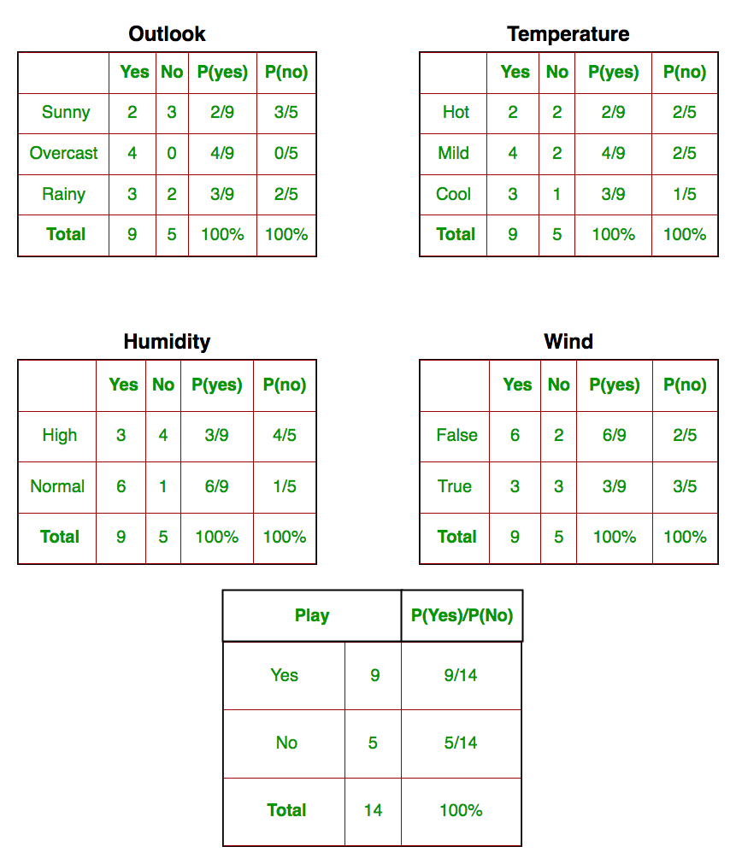

So, in the figure above, we have calculated P(xi | yj) for each xi in X and yj in y manually in the tables 1-4. For example, probability of playing golf given that the temperature is cool, i.e P(temp. = cool | play golf = Yes) = 3/9.

Also, we need to find class probabilities (P(y)) which has been calculated in the table 5. For example, P(play golf = Yes) = 9/14.

The method that we discussed above is applicable for discrete data. In case of continuous data, we need to make some assumptions regarding the distribution of values of each feature. The different naive Bayes classifiers differ mainly by the assumptions they make regarding the distribution of P(xi | y).

Now, we discuss one of such classifiers here.

**Gaussian Naive Bayes classifier**

In Gaussian Naive Bayes, continuous values associated with each feature are assumed to be distributed according to a **Gaussian distribution**. A Gaussian distribution is also called [Normal distribution](https://en.wikipedia.org/wiki/Normal_distribution). When plotted, it gives a bell shaped curve which is symmetric about the mean of the feature values as shown below:

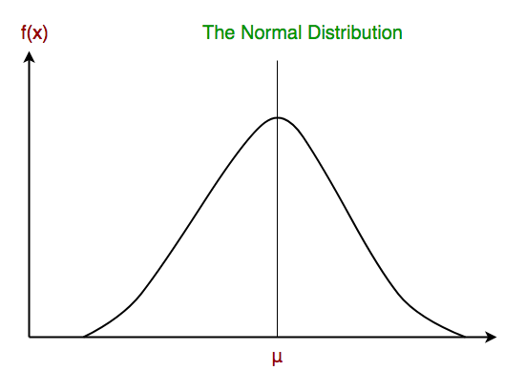

The likelihood of the features is assumed to be Gaussian, hence, conditional probability is given by:

Other popular Naive Bayes classifiers are:

* **Multinomial Naive Bayes**: Feature vectors represent the frequencies with which certain events have been generated by a **multinomial distribution**. This is the event model typically used for document classification.
* **Bernoulli Naive Bayes**: In the multivariate Bernoulli event model, features are independent booleans (binary variables) describing inputs. Like the multinomial model, this model is popular for document classification tasks, where binary term occurrence(i.e. a word occurs in a document or not) features are used rather than term frequencies(i.e. frequency of a word in the document).

As we reach to the end of this article, here are some important points to ponder upon:

* In spite of their apparently over-simplified assumptions, naive Bayes classifiers have worked quite well in many real-world situations, famously document classification and spam filtering. They require a small amount of training data to estimate the necessary parameters.
* Naive Bayes learners and classifiers can be extremely fast compared to more sophisticated methods. The decoupling of the class conditional feature distributions means that each distribution can be independently estimated as a one dimensional distribution. This in turn helps to alleviate problems stemming from the curse of dimensionality.

**Bayesian Belief Network**is a graphical representation of different probabilistic relationships among random variables in a particular set. It is a classifier with no dependency on attributes i.e it is condition independent. Due to its feature of joint probability, the probability in Bayesian Belief Network is derived, based on a condition — P(attribute/parent) i.e probability of an attribute, true over parent attribute.

(Note: A classifier assigns data in a collection to desired categories.)

* Consider this example:

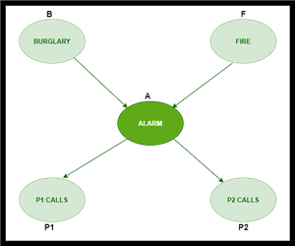

* In the above figure, we have an alarm ‘A’ – a node, say installed in a house of a person ‘gfg’, which rings upon two probabilities i.e burglary ‘B’ and fire ‘F’, which are – parent nodes of the alarm node. The alarm is the parent node of two probabilities P1 calls  ‘P1’ & P2 calls ‘P2’ person nodes.
* Upon the instance of burglary and fire, ‘P1’ and ‘P2’ call person ‘gfg’, respectively. But, there are few drawbacks in this case, as sometimes ‘P1’ may forget to call the person ‘gfg’, even after hearing the alarm, as he has a tendency to forget things, quick.  Similarly, ‘P2’, sometimes fails to call the person ‘gfg’, as he is only able to hear the alarm, from a certain distance.

**Q)** Find the probability that ‘P1’ is true (P1 has called ‘gfg’), ‘P2’ is true (P2 has called ‘gfg’) when the alarm ‘A’ rang, but no burglary ‘B’ and fire ‘F’ has occurred.

=> **P ( P1, P2, A, ~B, ~F)** [ where- P1, P2 & A are ‘true’ events and ‘~B’ & ‘~F’ are ‘false’ events]

[ **Note:** The values mentioned below are neither calculated nor computed. They have observed values ]

***Burglary ‘B’ –***

* **P (B=T) = 0.001** (‘B’ is true i.e burglary has occurred)
* **P (B=F) = 0.999**(‘B’ is false i.e burglary has not occurred)

***Fire ‘F’ –***

* **P (F=T) = 0.002** (‘F’ is true i.e fire has occurred)
* **P (F=F) = 0.998** (‘F’ is false i.e fire has not occurred)

***Alarm ‘A’ –***

|  |  |  |  |
| --- | --- | --- | --- |
| **B** | **F** | **P (A=T)** | **P (A=F)** |
| T | T | 0.95 | 0.05 |
| T | F | 0.94 | 0.06 |
| F | T | 0.29 | 0.71 |
| F | F | 0.001 | **0.999** |

* The alarm ‘A’ node can be ‘true’ or ‘false’ ( i.e may have rung or may not have rung). It has two parent nodes burglary ‘B’ and fire ‘F’ which can be ‘true’ or ‘false’ (i.e may have occurred or may not have occurred) depending upon different conditions.

***Person ‘P1’ –***

|  |  |  |
| --- | --- | --- |
| **A** | **P (P1=T)** | **P (P1=F)** |
| T | **0.95** | 0.05 |
| F | 0.05 | 0.95 |

* The person ‘P1’ node can be ‘true’ or ‘false’ (i.e may have called the person ‘gfg’ or not) . It has a parent node, the alarm ‘A’, which can be ‘true’ or ‘false’ (i.e may have rung or may not have rung ,upon burglary ‘B’ or fire ‘F’).

***Person ‘P2’ –***

|  |  |  |
| --- | --- | --- |
| **A** | **P (P2=T)** | **P (P2=F)** |
| T | **0.80** | 0.20 |
| F | 0.01 | 0.99 |

* The person ‘P2’ node can be ‘true’ or false’ (i.e may have called the person ‘gfg’ or not). It has a parent node, the alarm ‘A’, which can be ‘true’ or ‘false’ (i.e may have rung or may not have rung, upon burglary ‘B’ or fire ‘F’).

**Solution:** Considering the observed probabilistic scan –

With respect to the question —  **P ( P1, P2, A, ~B, ~F)**, we need to get the probability of ‘P1’. We find it with regard to its parent node – alarm ‘A’. To get the probability of ‘P2’, we find it with regard to its parent node — alarm ‘A’.

We find the probability of alarm ‘A’ node with regard to ‘~B’ & ‘~F’ since burglary ‘B’ and fire ‘F’ are parent nodes of alarm ‘A’.

From the observed probabilistic scan, we can deduce –

**P ( P1, P2, A, ~B, ~F)**

**= P (P1/A) * P (P2/A) * P (A/~B~F) * P (~B) * P (~F)**

**= 0.95 * 0.80 * 0.001 * 0.999 * 0.998**

**= 0.00075**

Introduction to Reinforcement Learning:

Reinforcement learning is an area of Machine Learning. It is about taking suitable action to maximize reward in a particular situation. It is employed by various software and machines to find the best possible behavior or path it should take in a specific situation. Reinforcement learning differs from supervised learning in a way that in supervised learning the training data has the answer key with it so the model is trained with the correct answer itself whereas in reinforcement learning, there is no answer but the reinforcement agent decides what to do to perform the given task. In the absence of a training dataset, it is bound to learn from its experience.

**Example:**The problem is as follows: We have an agent and a reward, with many hurdles in between. The agent is supposed to find the best possible path to reach the reward. The following problem explains the problem more easily.



The above image shows the robot, diamond, and fire. The goal of the robot is to get the reward that is the diamond and avoid the hurdles that are fired. The robot learns by trying all the possible paths and then choosing the path which gives him the reward with the least hurdles. Each right step will give the robot a reward and each wrong step will subtract the reward of the robot. The total reward will be calculated when it reaches the final reward that is the diamond.

**Main points in Reinforcement learning –** 

* Input: The input should be an initial state from which the model will start
* Output: There are many possible outputs as there are a variety of solutions to a particular problem
* Training: The training is based upon the input, The model will return a state and the user will decide to reward or punish the model based on its output.
* The model keeps continues to learn.
* The best solution is decided based on the maximum reward.

**Difference between Reinforcement learning and Supervised learning:**

| Reinforcement learning | Supervised learning |
| --- | --- |
| Reinforcement learning is all about making decisions sequentially. In simple words, we can say that the output depends on the state of the current input and the next input depends on the output of the previous input | In Supervised learning, the decision is made on the initial input or the input given at the start |
| In Reinforcement learning decision is dependent, So we give labels to sequences of dependent decisions | In supervised learning the decisions are independent of each other so labels are given to each decision. |
| Example: Chess game | Example: Object recognition |

**Types of Reinforcement:** There are two types of Reinforcement: 

1. **Positive –**   
   Positive Reinforcement is defined as when an event, occurs due to a particular behavior, increases the strength and the frequency of the behavior. In other words, it has a positive effect on behavior.

Advantages of reinforcement learning are:

* + Maximizes Performance
  + Sustain Change for a long period of time
  + Too much Reinforcement can lead to an overload of states which can diminish the results

1. **Negative –**   
   Negative Reinforcement is defined as strengthening of behavior because a negative condition is stopped or avoided.

Advantages of reinforcement learning:

* + Increases Behavior
  + Provide defiance to a minimum standard of performance
  + It Only provides enough to meet up the minimum behavior

**Various Practical applications of Reinforcement Learning –** 

* RL can be used in robotics for industrial automation.
* RL can be used in machine learning and data processing
* RL can be used to create training systems that provide custom instruction and materials according to the requirement of students.

RL can be used in large environments in the following situations: 

1. A model of the environment is known, but an analytic solution is not available;
2. Only a simulation model of the environment is given (the subject of simulation-based optimization)
3. The only way to collect information about the environment is to interact with it.

A **Markov Decision Process (MDP)** model contains: 

* A set of possible world states S.
* A set of Models.
* A set of possible actions A.
* A real-valued reward function R(s,a).
* A policy the solution of **Markov Decision Process**.

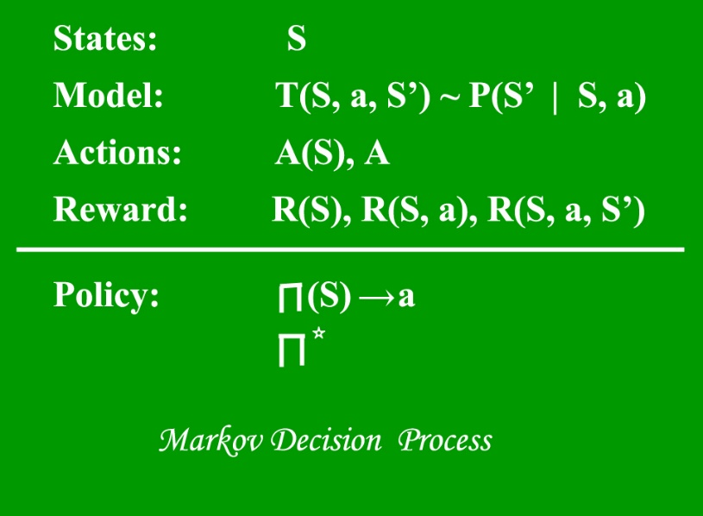

What is a State?

A **State** is a set of tokens that represent every state that the agent can be in.

### What is a Model? A **Model** (sometimes called Transition Model) gives an action’s effect in a state. In particular, T(S, a, S’) defines a transition T where being in state S and taking an action ‘a’ takes us to state S’ (S and S’ may be the same). For stochastic actions (noisy, non-deterministic) we also define a probability P(S’|S,a) which represents the probability of reaching a state S’ if action ‘a’ is taken in state S. Note Markov property states that the effects of an action taken in a state depend only on that state and not on the prior history.

 What are Actions?

An **Action** A is a set of all possible actions. A(s) defines the set of actions that can be taken being in state S.

 What is a Reward?

A **Reward** is a real-valued reward function. R(s) indicates the reward for simply being in the state S. R(S,a) indicates the reward for being in a state S and taking an action ‘a’. R(S,a,S’) indicates the reward for being in a state S, taking an action ‘a’ and ending up in a state S’.

What is a Policy?

A **Policy** is a solution to the Markov Decision Process. A policy is a mapping from S to a. It indicates the action ‘a’ to be taken while in state S.   
Let us take the example of a grid world:

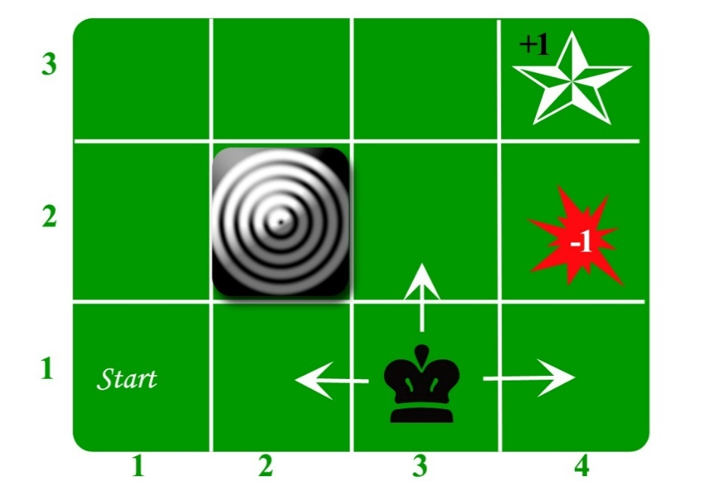

An agent lives in the grid. The above example is a 3*4 grid. The grid has a START state(grid no 1,1). The purpose of the agent is to wander around the grid to finally reach the Blue Diamond (grid no 4,3). Under all circumstances, the agent should avoid the Fire grid (orange color, grid no 4,2). Also the grid no 2,2 is a blocked grid, it acts as a wall hence the agent cannot enter it.

The agent can take any one of these actions: **UP, DOWN, LEFT, RIGHT**

Walls block the agent path, i.e., if there is a wall in the direction the agent would have taken, the agent stays in the same place. So for example, if the agent says LEFT in the START grid he would stay put in the START grid.

**First Aim:** To find the shortest sequence getting from START to the Diamond. Two such sequences can be found: 

* **RIGHT RIGHT UP UPRIGHT**
* **UP UP RIGHT RIGHT RIGHT**

Let us take the second one (UP UP RIGHT RIGHT RIGHT) for the subsequent discussion.   
The move is now noisy. 80% of the time the intended action works correctly. 20% of the time the action agent takes causes it to move at right angles. For example, if the agent says UP the probability of going UP is 0.8 whereas the probability of going LEFT is 0.1, and the probability of going RIGHT is 0.1 (since LEFT and RIGHT are right angles to UP).

The agent receives rewards each time step:- 

* Small reward each step (can be negative when can also be term as punishment, in the above example entering the Fire can have a reward of -1).
* Big rewards come at the end (good or bad).
* The goal is to Maximize the sum of rewards.

## **Temporal Difference (TD)**

Simple Introduction

So to discuss these algorithms I’m going to try and explain them in a simple way. Feel free to reference the David Silver lectures or the Sutton and Barto book for more depth. Temporal difference is an agent learning from an environment through episodes with no prior knowledge of the environment. This means temporal difference takes a model-free or unsupervised learning approach. You can consider it learning from trial and error.

Let’s Learn Greek

You will notice in this post some notation and we’ll discuss 3 algorithms: TD(0), TD(1) and TD(λ). I will show the equations for each of these and we’ll explain them, but lets quickly define the notation for at least some of the hyper parameters (greek letters that are sometimes intimidating).

1. **Gamma (γ):** the discount rate. A value between 0 and 1. The higher the value the less you are discounting.
2. **Lambda (λ):** the credit assignment variable. A value between 0 and 1. The higher the value the more credit you can assign to further back states and actions.
3. **Alpha (α):** the learning rate. How much of the error should we accept and therefore adjust our estimates towards. A value between 0 and 1. A higher value adjusts aggressively, accepting more of the error while a smaller one adjusts conservatively but may make more conservative moves towards the actual values.
4. **Delta (δ):** a change or difference in value.

## **TD(1) Algorithm**

So the first algorithm we’ll start with will be TD(1). TD(1) makes an update to our values in the same manner as Monte Carlo, at the end of an episode. So back to our random walk, going left or right randomly, until landing in ‘A’ or ‘G’. Once the episode ends then the update is made to the prior states. As we mentioned above if the higher the lambda value the further the credit can be assigned and in this case its the extreme with lambda equaling 1. This is an important distinction because TD(1) and MC only work in episodic environments meaning they need a ‘finish line’ to make an update.

Now lets look at the algorithm and try and make sense of this. Gt (Figure 2) is the discounted sum of all the rewards seen in our episode. So as we’re traveling through our environment we keep track of all the rewards and sum them together with a discount (γ). So lets act like we’re reading this out loud: the immediate reward (R) at a given point (time, t+1) plus the discount (γ) of a future reward (Rt+2) and so on. You can see that we discount (γ) more heavily in the future with γ^T-1. So if γ=0.2 and you’re discounting the reward at time step 6, your discount value γ become γ^6–1 which equals 0.00032. Significantly smaller after just 6 time steps.



Figure 2: Sum of Discounted Rewards

Now we’ll make an update to our value estimates V(S). **Its important to know that when starting out you really don’t have a good starting estimate. You initialize using either random values or all zeros and then make updates to that estimate**. For our random walk sequence we initialize values for all the states between ‘B’ and ‘F’ to zero [0,0,0,0,0,0,1] . We’ll leave the terminal states alone since those are known. Remember we’re only trying to predict the values for the non-terminal states since we know the value of the terminal states.

We’ll use the sum of discounted rewards from above, Gt, that we saw from our episode and we’ll subtract that from the prior estimate. This is called the TD Error. Our updated estimate minus the previous estimate. Then we multiple by an alpha (α) term to adjust how much of that error we want to update by. Lastly we make the update by simply adding our pervious estimate V(St) to the adjusted TD Error (Figure 3).



Figure 3: TD(1) Update Value toward Action Return

So thats 1 episode. We did 1 random walk and accumulated rewards. We then took those rewards at each time step and compared it to our original estimate of values (all zeros). We weight the difference and adjust our prior estimate. Then start over again. You just learned the TD(1) or MC update!

## **TD(0) Algorithm**

Now that we’ve explained TD(1), TD(0) will be much easier to understand. Lets look inside the parenthesis fo Figure 3 cause thats the only difference. Instead of using the accumulated sum of discounted rewards (Gt) we will only look at the immediate reward (Rt+1), plus the discount of the estimated value of **only 1 step ahead** (V(St+1)) (Figure 4).



Figure 4: TD(0) Update Value toward Estimated Return

This is the only difference between the TD(0) and TD(1) update. Notice we just swapped out Gt, from Figure 3, with the one step ahead estimation.

When we use estimates to update estimates we call this bootstrapping. This type of technique has a higher bias then TD(1) or MC because you’re making estimates from estimates versus estimates from seeing an entire episode. However, this tends to have lower variance. Another benefit of TD(0) is that it can learn environments that do not have terminal states where TD(1) can not.

## **TD(λ) Algorithm**

Lets say we want to make value updates before the end of an episode (TD(1)) and use more than a 1 step ahead (TD(0)) for our estimation. This is where TD(λ) comes in. You should know that there are 2 implementations of TD(λ): forward and backward view. The forward view looks at all n-steps ahead and uses λ to essentially decay those future estimates. For this post we’ll stay with the backward view of TD(λ), but it has been proven that both forward and backward view are equivalent and Sutton shows that [here](http://incompleteideas.net/book/ebook/node76.html) if interested.

The backward view of TD(λ) updates values at each step. So after each step in the episode you make updates to all prior steps. The question is how do you weight or assign credit to all prior steps appropriately? The answer is by using something called Eligibility Traces (ET). ET basically keeps a record of the frequency and recency of entering a given state (Figure 4). It assigns credit to states that are both visited frequently as well as visited recently with respect to our terminal state. The lambda (λ) and gamma (γ) term are used to discount those traces.

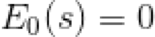



Figure 4: Eligibility Traces

If you think about this intuitively we know that state ‘F’ will be visited frequently and recently with respect to ending in our final state ‘G’ and therefore will receive many updates. Therefore ET will assign more credit to state ‘F’ in proportion to the TD Error (Figure 5, αδtEt(s)). However, state ‘B’ will not be visited as often with respect to terminating in state ‘G’ so the value of that state will not be updated as often and will remain close to 0 where it was initialized. From here we make continuous updates to our prior estimates.





Figure 5: Update with Respect to TD Error (δt) and Eligibility (Et(s))

## **Summary**

So thats temporal difference learning in a simplified manner, I hope. The gist of it is we make an initial estimate, explore a space, and update our prior estimate based on our exploration efforts. The difficult part of Reinforcement Learning seems to be where to apply it, what is the environment, how do I set up my rewards properly, etc, but at least for now you understand the exploration of a state space and making estimates with an unsupervised model-free approach

Reinforcement Q Learning

*Teach a Taxi to pick up and drop off passengers at the right locations with Reinforcement Learning*

Most of you have probably heard of AI learning to play computer games on their own, a very popular example being Deepmind. Deepmind hit the news when their AlphaGo program defeated the South Korean Go world champion in 2016. There had been many successful attempts in the past to develop agents with the intent of playing Atari games like Breakout, Pong, and Space Invaders.

Each of these programs follow a paradigm of Machine Learning known as **Reinforcement Learning**. If you've never been exposed to reinforcement learning before, the following is a very straightforward analogy for how it works.

# Reinforcement Learning Analogy

Consider the scenario of teaching a dog new tricks. The dog doesn't understand our language, so we can't tell him what to do. Instead, we follow a different strategy. We emulate a situation (or a cue), and the dog tries to respond in many different ways. If the dog's response is the desired one, we reward them with snacks. Now guess what, the next time the dog is exposed to the same situation, the dog executes a similar action with even more enthusiasm in expectation of more food. That's like learning "what to do" from positive experiences. Similarly, dogs will tend to learn what not to do when face with negative experiences.

That's exactly how Reinforcement Learning works in a broader sense:

* Your dog is an "agent" that is exposed to the **environment**. The environment could be your house, with you.
* The situations they encounter are analogous to a **state**. An example of a state could be your dog standing and you use a specific word in a certain tone in your living room
* Our agents react by performing an **action** to transition from one "state" to another "state," your dog goes from standing to sitting, for example.
* After the transition, they may receive a **reward** or **penalty** in return. You give them a treat! Or a "No" as a penalty.
* The **policy** is the strategy of choosing an action given a state in expectation of better outcomes.

Reinforcement Learning lies between the spectrum of Supervised Learning and Unsupervised Learning, and there's a few important things to note:

1. **Being greedy doesn't always work**  
   There are things that are easy to do for instant gratification, and there's things that provide long term rewards The goal is to not be greedy by looking for the quick immediate rewards, but instead to optimize for maximum rewards over the whole training.
2. **Sequence matters in Reinforcement Learning**  
   The reward agent does not just depend on the current state, but the entire history of states. Unlike supervised and unsupervised learning, time is important here.

**The Reinforcement Learning Process**



In a way, Reinforcement Learning is the science of making optimal decisions using experiences. Breaking it down, the process of Reinforcement Learning involves these simple steps:

1. Observation of the environment
2. Deciding how to act using some strategy
3. Acting accordingly
4. Receiving a reward or penalty
5. Learning from the experiences and refining our strategy
6. Iterate until an optimal strategy is found

Let's now understand Reinforcement Learning by actually developing an agent to learn to play a game automatically on its own.

**Example Design: Self-Driving Cab**

Let's design a simulation of a self-driving cab. The major goal is to demonstrate, in a simplified environment, how you can use RL techniques to develop an efficient and safe approach for tackling this problem.

The Smartcab's job is to pick up the passenger at one location and drop them off in another. Here are a few things that we'd love our Smartcab to take care of:

* Drop off the passenger to the right location.
* Save passenger's time by taking minimum time possible to drop off
* Take care of passenger's safety and traffic rules

There are different aspects that need to be considered here while modeling an RL solution to this problem: rewards, states, and actions.

**1. Rewards**

Since the agent (the imaginary driver) is reward-motivated and is going to learn how to control the cab by trial experiences in the environment, we need to decide the **rewards** and/or **penalties** and their magnitude accordingly. Here a few points to consider:

* The agent should receive a high positive reward for a successful dropoff because this behavior is highly desired
* The agent should be penalized if it tries to drop off a passenger in wrong locations
* The agent should get a slight negative reward for not making it to the destination after every time-step. "Slight" negative because we would prefer our agent to reach late instead of making wrong moves trying to reach to the destination as fast as possible

**2. State Space**

In Reinforcement Learning, the agent encounters a state, and then takes action according to the state it's in.

The **State Space** is the set of all possible situations our taxi could inhabit. The state should contain useful information the agent needs to make the right action.

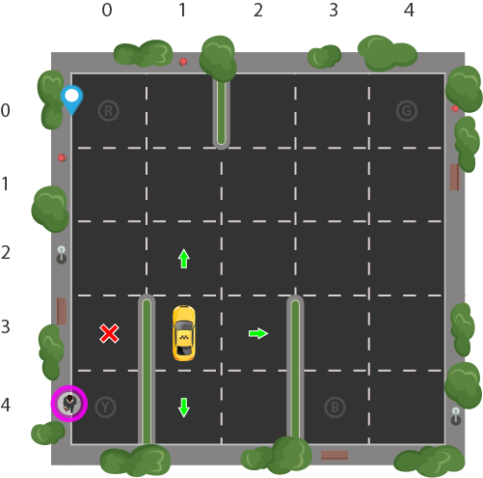Let's say we have a training area for our Smartcab where we are teaching it to transport people in a parking lot to four different locations (R, G, Y, B):

Let's assume Smartcab is the only vehicle in this parking lot. We can break up the parking lot into a 5x5 grid, which gives us 25 possible taxi locations. These 25 locations are one part of our state space. Notice the current location state of our taxi is coordinate (3, 1).

You'll also notice there are four (4) locations that we can pick up and drop off a passenger: R, G, Y, B or [(0,0), (0,4), (4,0), (4,3)] in (row, col) coordinates. Our illustrated passenger is in location **Y** and they wish to go to location **R**.

When we also account for one (1) additional passenger state of being inside the taxi, we can take all combinations of passenger locations and destination locations to come to a total number of states for our taxi environment; there's four (4) destinations and five (4 + 1) passenger locations.

So, our taxi environment has 5×5×5×4=500 total possible states.

The agent encounters one of the 500 states and it takes an action. The action in our case can be to move in a direction or decide to pickup/dropoff a passenger.

In other words, we have six possible actions:

1. south
2. north
3. east
4. west
5. pickup
6. dropoff

This is the **action space**: the set of all the actions that our agent can take in a given state.

You'll notice in the illustration above, that the taxi cannot perform certain actions in certain states due to walls. In the environment's code, we will simply provide a -1 penalty for every wall hit and the taxi won't move anywhere. This will just rack up penalties causing the taxi to consider going around the wall.

**3. Action Space**

The agent encounters one of the 500 states and it takes an action. The action in our case can be to move in a direction or decide to pickup/dropoff a passenger.

In other words, we have six possible actions:

1. south
2. north
3. east
4. west
5. pickup
6. dropoff

This is the **action space**: the set of all the actions that our agent can take in a given state.

You'll notice in the illustration above, that the taxi cannot perform certain actions in certain states due to walls. In the environment's code, we will simply provide a -1 penalty for every wall hit and the taxi won't move anywhere. This will just rack up penalties causing the taxi to consider going around the wall.

**Implementation with Python**

Fortunately, [OpenAI Gym](https://gym.openai.com/) has this exact environment already built for us.

Gym provides different game environments which we can plug into our code and test an agent. The library takes care of API for providing all the information that our agent would require, like possible actions, score, and current state. We just need to focus just on the algorithm part for our agent.

We'll be using the Gym environment called Taxi-V2, which all of the details explained above were pulled from. The objectives, rewards, and actions are all the same.

**Gym's interface**

We need to install gym first. Executing the following in a Jupyter notebook should work:

!pip install cmake 'gym[atari]' scipy

Once installed, we can load the game environment and render what it looks like:

import gym

env = gym.make("Taxi-v2").env

env.render()

+---------+

|R: | : :**G**|

| : : : : |

| : : : : |

| | : | : |

|Y| : |B: |

+---------+

The core gym interface is env, which is the unified environment interface. The following are the env methods that would be quite helpful to us:

* env.reset: Resets the environment and returns a random initial state.
* env.step(action): Step the environment by one timestep. Returns
  + **observation**: Observations of the environment
  + **reward**: If your action was beneficial or not
  + **done**: Indicates if we have successfully picked up and dropped off a passenger, also called one *episode*
  + **info**: Additional info such as performance and latency for debugging purposes
* env.render: Renders one frame of the environment (helpful in visualizing the environment)

Note: We are using the .env on the end of make to avoid training stopping at 200 iterations, which is the default for the new version of Gym ([reference](https://stackoverflow.com/a/42802225)).

**Reminder of our problem**

Here's our restructured problem statement (from Gym docs):

*"There are 4 locations (labeled by different letters), and our job is to pick up the passenger at one location and drop him off at another. We receive +20 points for a successful drop-off and lose 1 point for every time-step it takes. There is also a 10 point penalty for illegal pick-up and drop-off actions."*

Let's dive more into the environment.

env.reset() # reset environment to a new, random state

env.render()

print("Action Space {}".format(env.action_space))

print("State Space {}".format(env.observation_space))

+---------+

|R: | : :G|

| : : : : |

| : : : : |

| | : | : |

|Y| : |**B**: |

+---------+

Action Space Discrete(6)

State Space Discrete(500)

* The **filled square** represents the taxi, which is yellow without a passenger and green with a passenger.
* The **pipe ("|")** represents a wall which the taxi cannot cross.
* **R, G, Y, B** are the possible pickup and destination locations. The **blue letter** represents the current passenger pick-up location, and the **purple letter** is the current destination.

As verified by the prints, we have an **Action Space** of size 6 and a **State Space** of size 500. As you'll see, our RL algorithm won't need any more information than these two things. All we need is a way to identify a state uniquely by assigning a unique number to every possible state, and RL learns to choose an action number from 0-5 where:

* 0 = south
* 1 = north
* 2 = east
* 3 = west
* 4 = pickup
* 5 = dropoff

Recall that the 500 states correspond to a encoding of the taxi's location, the passenger's location, and the destination location.

Reinforcement Learning will learn a mapping of **states** to the optimal **action** to perform in that state by *exploration*, i.e. the agent explores the environment and takes actions based off rewards defined in the environment.

The optimal action for each state is the action that has the **highest cumulative long-term reward**.

**Back to our illustration**

We can actually take our illustration above, encode its state, and give it to the environment to render in Gym. Recall that we have the taxi at row 3, column 1, our passenger is at location 2, and our destination is location 0. Using the Taxi-v2 state encoding method, we can do the following:

state = env.encode(3, 1, 2, 0) # (taxi row, taxi column, passenger index, destination index)

print("State:", state)

env.s = state

env.render()

State: 328

+---------+

|R: | : :G|

| : : : : |

| : : : : |

| | : | : |

|**Y**| : |B: |

+---------+

We are using our illustration's coordinates to generate a number corresponding to a state between 0 and 499, which turns out to be **328** for our illustration's state.

Then we can set the environment's state manually with env.env.s using that encoded number. You can play around with the numbers and you'll see the taxi, passenger, and destination move around.

**The Reward Table**

When the Taxi environment is created, there is an initial Reward table that's also created, called `P`. We can think of it like a matrix that has the number of states as rows and number of actions as columns, i.e. a states × actionsstates × actions matrix.

Since every state is in this matrix, we can see the default reward values assigned to our illustration's state:

env.P[328]

**OUT:**

{0: [(1.0, 428, -1, False)],

 1: [(1.0, 228, -1, False)],

 2: [(1.0, 348, -1, False)],

 3: [(1.0, 328, -1, False)],

 4: [(1.0, 328, -10, False)],

 5: [(1.0, 328, -10, False)]}

This dictionary has the structure {action: [(probability, nextstate, reward, done)]}.

A few things to note:

* The 0-5 corresponds to the actions (south, north, east, west, pickup, dropoff) the taxi can perform at our current state in the illustration.
* In this env, probability is always 1.0.
* The nextstate is the state we would be in if we take the action at this index of the dict
* All the movement actions have a -1 reward and the pickup/dropoff actions have -10 reward in this particular state. If we are in a state where the taxi has a passenger and is on top of the right destination, we would see a reward of 20 at the dropoff action (5)
* done is used to tell us when we have successfully dropped off a passenger in the right location. Each successfull dropoff is the end of an **episode**

Note that if our agent chose to explore action two (2) in this state it would be going East into a wall. The source code has made it impossible to actually move the taxi across a wall, so if the taxi chooses that action, it will just keep accruing -1 penalties, which affects the **long-term reward**.

**Solving the environment without Reinforcement Learning**

Let's see what would happen if we try to brute-force our way to solving the problem without RL.

Since we have our P table for default rewards in each state, we can try to have our taxi navigate just using that.

We'll create an infinite loop which runs until one passenger reaches one destination (one **episode**), or in other words, when the received reward is 20. The env.action_space.sample() method automatically selects one random action from set of all possible actions.

Let's see what happens:

env.s = 328  # set environment to illustration's state

epochs = 0

penalties, reward = 0, 0

frames = [] # for animation

done = False

while not done:

    action = env.action_space.sample()

    state, reward, done, info = env.step(action)

    if reward == -10:

        penalties += 1

    # Put each rendered frame into dict for animation

    frames.append({

        'frame': env.render(mode='ansi'),

        'state': state,

        'action': action,

        'reward': reward

        }

    )

    epochs += 1

print("Timesteps taken: {}".format(epochs))

print("Penalties incurred: {}".format(penalties))

**OUT:**

Time steps taken: 1117

Penalties incurred: 363

from IPython.display import clear_output

from time import sleep

def print_frames(frames):

    for i, frame in enumerate(frames):

        clear_output(wait=True)

        print(frame['frame'].getvalue())

        print(f"Timestep: {i + 1}")

        print(f"State: {frame['state']}")

        print(f"Action: {frame['action']}")

        print(f"Reward: {frame['reward']}")

        sleep(.1)

print_frames(frames)



Not good. Our agent takes thousands of timesteps and makes lots of wrong drop offs to deliver just one passenger to the right destination.

This is because we aren't *learning* from past experience. We can run this over and over, and it will never optimize. The agent has no memory of which action was best for each state, which is exactly what Reinforcement Learning will do for us.

**Enter Reinforcement Learning**

We are going to use a simple RL algorithm called *Q-learning* which will give our agent some memory.

**Intro to Q-learning**

Essentially, Q-learning lets the agent use the environment's rewards to learn, over time, the best action to take in a given state.

In our Taxi environment, we have the reward table, P, that the agent will learn from. It does thing by looking receiving a reward for taking an action in the current state, then updating a *Q-value* to remember if that action was beneficial.

The values store in the Q-table are called a *Q-values*, and they map to a (state, action) combination.

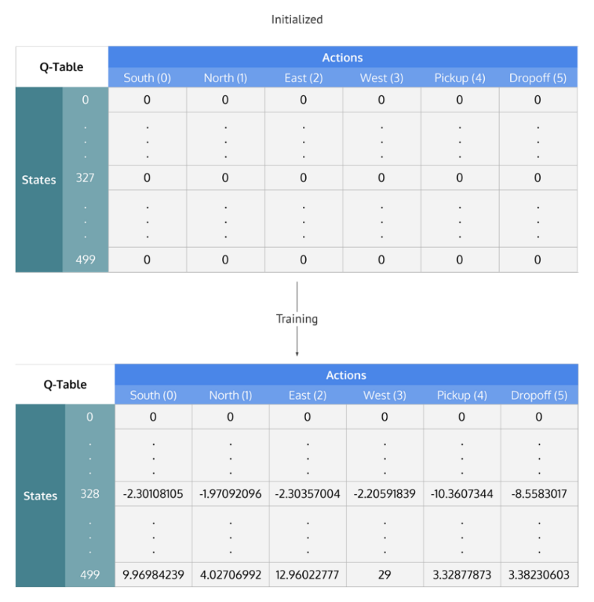A Q-value for a particular state-action combination is representative of the "quality" of an action taken from that state. Better Q-values imply better chances of getting greater rewards.

For example, if the taxi is faced with a state that includes a passenger at its current location, it is highly likely that the Q-value for pickup is higher when compared to other actions, like dropoff or north.

Q-values are initialized to an arbitrary value, and as the agent exposes itself to the environment and receives different rewards by executing different actions, the Q-values are updated using the equation:

Q(state,action)←(1−α)Q(state,action)+α(reward+γmaxaQ(next state,all actions))Q(state,action)←(1−α)Q(state,action)+α(reward+γmaxaQ(next state,all actions))

Where:

- αα (alpha) is the learning rate (0<α≤10<α≤1) - Just like in supervised learning settings, αα is the extent to which our Q-values are being updated in every iteration.

- γγ (gamma) is the discount factor (0≤γ≤10≤γ≤1) - determines how much importance we want to give to future rewards. A high value for the discount factor (close to **1**) captures the long-term effective award, whereas, a discount factor of **0** makes our agent consider only immediate reward, hence making it greedy.

**What is this saying?**

We are assigning (←←), or updating, the Q-value of the agent's current *state* and *action* by first taking a weight (1−α1−α) of the old Q-value, then adding the learned value. The learned value is a combination of the reward for taking the current action in the current state, and the discounted maximum reward from the next state we will be in once we take the current action.

Basically, we are learning the proper action to take in the current state by looking at the reward for the current state/action combo, and the max rewards for the next state. This will eventually cause our taxi to consider the route with the best rewards strung together.

The Q-value of a state-action pair is the sum of the instant reward and the discounted future reward (of the resulting state). The way we store the Q-values for each state and action is through a **Q-table**

Q-Table

The Q-table is a matrix where we have a row for every state (500) and a column for every action (6). It's first initialized to 0, and then values are updated after training. Note that the Q-table has the same dimensions as the reward table, but it has a completely different purpose.

Q-Table values are initialized to zero and then updated during training to values that optimize the agent's traversal through the environment for maximum rewards

**Summing up the Q-Learning Process**

Breaking it down into steps, we get

* Initialize the Q-table by all zeros.
* Start exploring actions: For each state, select any one among all possible actions for the current state (S).
* Travel to the next state (S') as a result of that action (a).
* For all possible actions from the state (S') select the one with the highest Q-value.
* Update Q-table values using the equation.
* Set the next state as the current state.
* If goal state is reached, then end and repeat the process.

Exploiting learned values

After enough random exploration of actions, the Q-values tend to converge serving our agent as an action-value function which it can exploit to pick the most optimal action from a given state.

There's a tradeoff between exploration (choosing a random action) and exploitation (choosing actions based on already learned Q-values). We want to prevent the action from always taking the same route, and possibly overfitting, so we'll be introducing another parameter called ϵϵ "epsilon" to cater to this during training.

Instead of just selecting the best learned Q-value action, we'll sometimes favor exploring the action space further. Lower epsilon value results in episodes with more penalties (on average) which is obvious because we are exploring and making random decisions.

**Implementing Q-learning in python**

**Training the Agent**

First, we'll initialize the Q-table to a 500×6500×6 matrix of zeros:

import numpy as np

q_table = np.zeros([env.observation_space.n, env.action_space.n])

We can now create the training algorithm that will update this Q-table as the agent explores the environment over thousands of episodes.

In the first part of while not done, we decide whether to pick a random action or to exploit the already computed Q-values. This is done simply by using the epsilon value and comparing it to the random.uniform(0, 1) function, which returns an arbitrary number between 0 and 1.

We execute the chosen action in the environment to obtain the next_state and the reward from performing the action. After that, we calculate the maximum Q-value for the actions corresponding to the next_state, and with that, we can easily update our Q-value to the new_q_value:

%%time

"""Training the agent"""

import random

from IPython.display import clear_output

# Hyperparameters

alpha = 0.1

gamma = 0.6

epsilon = 0.1

# For plotting metrics

all_epochs = []

all_penalties = []

for i in range(1, 100001):

    state = env.reset()

    epochs, penalties, reward, = 0, 0, 0

    done = False

    while not done:

        if random.uniform(0, 1) < epsilon:

            action = env.action_space.sample() # Explore action space

        else:

            action = np.argmax(q_table[state]) # Exploit learned values

        next_state, reward, done, info = env.step(action)

        old_value = q_table[state, action]

        next_max = np.max(q_table[next_state])

        new_value = (1 - alpha) * old_value + alpha * (reward + gamma * next_max)

        q_table[state, action] = new_value

        if reward == -10:

            penalties += 1

        state = next_state

        epochs += 1

    if i % 100 == 0:

        clear_output(wait=True)

        print(f"Episode: {i}")

print("Training finished.\n")

**OUT:**

Episode: 100000

Training finished.

Wall time: 30.6 s

Now that the Q-table has been established over 100,000 episodes, let's see what the Q-values are at our illustration's state:

q_table[328]

**OUT:**

array([ -2.30108105,  -1.97092096,  -2.30357004,  -2.20591839,

       -10.3607344 ,  -8.5583017 ])

The max Q-value is "north" (-1.971), so it looks like Q-learning has effectively learned the best action to take in our illustration's state!

**Evaluating the agent**

Let's evaluate the performance of our agent. We don't need to explore actions any further, so now the next action is always selected using the best Q-value:

"""Evaluate agent's performance after Q-learning"""

total_epochs, total_penalties = 0, 0

episodes = 100

for _ in range(episodes):

    state = env.reset()

    epochs, penalties, reward = 0, 0, 0

    done = False

    while not done:

        action = np.argmax(q_table[state])

        state, reward, done, info = env.step(action)

        if reward == -10:

            penalties += 1

        epochs += 1

    total_penalties += penalties

    total_epochs += epochs

print(f"Results after {episodes} episodes:")

print(f"Average timesteps per episode: {total_epochs / episodes}")

print(f"Average penalties per episode: {total_penalties / episodes}")

**OUT:**

Results after 100 episodes:

Average timesteps per episode: 12.3

Average penalties per episode: 0.0

We can see from the evaluation, the agent's performance improved significantly and it incurred no penalties, which means it performed the correct pickup/dropoff actions with 100 different passengers.

**Comparing our Q-learning agent to no Reinforcement Learning**

With Q-learning agent commits errors initially during exploration but once it has explored enough (seen most of the states), it can act wisely maximizing the rewards making smart moves. Let's see how much better our Q-learning solution is when compared to the agent making just random moves.

We evaluate our agents according to the following metrics,

* **Average number of penalties per episode:** The smaller the number, the better the performance of our agent. Ideally, we would like this metric to be zero or very close to zero.
* **Average number of timesteps per trip:** We want a small number of timesteps per episode as well since we want our agent to take minimum steps(i.e. the shortest path) to reach the destination.
* **Average rewards per move:** The larger the reward means the agent is doing the right thing. That's why deciding rewards is a crucial part of Reinforcement Learning. In our case, as both timesteps and penalties are negatively rewarded, a higher average reward would mean that the agent reaches the destination as fast as possible with the least penalties"

|  |  |  |
| --- | --- | --- |
| **Measure** | **Random agent's performance** | **Q-learning agent's performance** |
| Average rewards per move | -3.9012092102214075 | 0.6962843295638126 |
| Average number of penalties per episode | 920.45 | 0.0 |
| Average number of timesteps per trip | 2848.14 | 12.38 |

These metrics were computed over 100 episodes. And as the results show, our Q-learning agent nailed it!

**Hyperparameters and optimizations**

The values of `alpha`, `gamma`, and `epsilon` were mostly based on intuition and some "hit and trial", but there are better ways to come up with good values.

Ideally, all three should decrease over time because as the agent continues to learn, it actually builds up more resilient priors;

* αα: (the learning rate) should decrease as you continue to gain a larger and larger knowledge base.
* γγ: as you get closer and closer to the deadline, your preference for near-term reward should increase, as you won't be around long enough to get the long-term reward, which means your gamma should decrease.
* ϵϵ: as we develop our strategy, we have less need of exploration and more exploitation to get more utility from our policy, so as trials increase, epsilon should decrease.

Tuning the hyperparameters

A simple way to programmatically come up with the best set of values of the hyperparameter is to create a comprehensive search function (similar to [grid search](https://en.wikipedia.org/wiki/Hyperparameter_optimization#Grid_search)) that selects the parameters that would result in best reward/time_steps ratio. The reason for reward/time_steps is that we want to choose parameters which enable us to get the maximum reward as fast as possible. We may want to track the number of penalties corresponding to the hyperparameter value combination as well because this can also be a deciding factor (we don't want our smart agent to violate rules at the cost of reaching faster). A more fancy way to get the right combination of hyperparameter values would be to use Genetic Algorithms.

**Conclusion and What's Ahead**

Alright! We began with understanding Reinforcement Learning with the help of real-world analogies. We then dived into the basics of Reinforcement Learning and framed a Self-driving cab as a Reinforcement Learning problem. We then used OpenAI's Gym in python to provide us with a related environment, where we can develop our agent and evaluate it. Then we observed how terrible our agent was without using any algorithm to play the game, so we went ahead to implement the Q-learning algorithm from scratch. The agent's performance improved significantly after Q-learning. Finally, we discussed better approaches for deciding the hyperparameters for our algorithm.

Q-learning is one of the easiest Reinforcement Learning algorithms. The problem with Q-earning however is, once the number of states in the environment are very high, it becomes difficult to implement them with Q table as the size would become very, very large. State of the art techniques uses Deep neural networks instead of the Q-table (Deep Reinforcement Learning). The neural network takes in state information and actions to the input layer and learns to output the right action over the time. Deep learning techniques (like Convolutional Neural Networks) are also used to interpret the pixels on the screen and extract information out of the game (like scores), and then letting the agent control the game.

We have discussed a lot about Reinforcement Learning and games. But Reinforcement learning is not just limited to games. It is used for managing stock portfolios and finances, for making humanoid robots, for manufacturing and inventory management, to develop general AI agents, which are agents that can perform multiple things with a single algorithm, like the same agent playing multiple Atari games. Open AI also has a platform called universe for measuring and training an AI's general intelligence across myriads of games, websites and other general applications.

Reinforcement Q Learning

*Teach a Taxi to pick up and drop off passengers at the right locations with Reinforcement Learning*

Most of you have probably heard of AI learning to play computer games on their own, a very popular example being Deepmind. Deepmind hit the news when their AlphaGo program defeated the South Korean Go world champion in 2016. There had been many successful attempts in the past to develop agents with the intent of playing Atari games like Breakout, Pong, and Space Invaders.

Each of these programs follow a paradigm of Machine Learning known as **Reinforcement Learning**. If you've never been exposed to reinforcement learning before, the following is a very straightforward analogy for how it works.

# Reinforcement Learning Analogy

Consider the scenario of teaching a dog new tricks. The dog doesn't understand our language, so we can't tell him what to do. Instead, we follow a different strategy. We emulate a situation (or a cue), and the dog tries to respond in many different ways. If the dog's response is the desired one, we reward them with snacks. Now guess what, the next time the dog is exposed to the same situation, the dog executes a similar action with even more enthusiasm in expectation of more food. That's like learning "what to do" from positive experiences. Similarly, dogs will tend to learn what not to do when face with negative experiences.

That's exactly how Reinforcement Learning works in a broader sense:

* Your dog is an "agent" that is exposed to the **environment**. The environment could be your house, with you.
* The situations they encounter are analogous to a **state**. An example of a state could be your dog standing and you use a specific word in a certain tone in your living room
* Our agents react by performing an **action** to transition from one "state" to another "state," your dog goes from standing to sitting, for example.
* After the transition, they may receive a **reward** or **penalty** in return. You give them a treat! Or a "No" as a penalty.
* The **policy** is the strategy of choosing an action given a state in expectation of better outcomes.

Reinforcement Learning lies between the spectrum of Supervised Learning and Unsupervised Learning, and there's a few important things to note:

1. **Being greedy doesn't always work**  
   There are things that are easy to do for instant gratification, and there's things that provide long term rewards The goal is to not be greedy by looking for the quick immediate rewards, but instead to optimize for maximum rewards over the whole training.
2. **Sequence matters in Reinforcement Learning**  
   The reward agent does not just depend on the current state, but the entire history of states. Unlike supervised and unsupervised learning, time is important here.

**The Reinforcement Learning Process**



In a way, Reinforcement Learning is the science of making optimal decisions using experiences. Breaking it down, the process of Reinforcement Learning involves these simple steps:

1. Observation of the environment
2. Deciding how to act using some strategy
3. Acting accordingly
4. Receiving a reward or penalty
5. Learning from the experiences and refining our strategy
6. Iterate until an optimal strategy is found

Let's now understand Reinforcement Learning by actually developing an agent to learn to play a game automatically on its own.

**Example Design: Self-Driving Cab**

Let's design a simulation of a self-driving cab. The major goal is to demonstrate, in a simplified environment, how you can use RL techniques to develop an efficient and safe approach for tackling this problem.

The Smartcab's job is to pick up the passenger at one location and drop them off in another. Here are a few things that we'd love our Smartcab to take care of:

* Drop off the passenger to the right location.
* Save passenger's time by taking minimum time possible to drop off
* Take care of passenger's safety and traffic rules

There are different aspects that need to be considered here while modeling an RL solution to this problem: rewards, states, and actions.

**1. Rewards**

Since the agent (the imaginary driver) is reward-motivated and is going to learn how to control the cab by trial experiences in the environment, we need to decide the **rewards** and/or **penalties** and their magnitude accordingly. Here a few points to consider:

* The agent should receive a high positive reward for a successful dropoff because this behavior is highly desired
* The agent should be penalized if it tries to drop off a passenger in wrong locations
* The agent should get a slight negative reward for not making it to the destination after every time-step. "Slight" negative because we would prefer our agent to reach late instead of making wrong moves trying to reach to the destination as fast as possible

**2. State Space**

In Reinforcement Learning, the agent encounters a state, and then takes action according to the state it's in.

The **State Space** is the set of all possible situations our taxi could inhabit. The state should contain useful information the agent needs to make the right action.

Let's say we have a training area for our Smartcab where we are teaching it to transport people in a parking lot to four different locations (R, G, Y, B):

Let's assume Smartcab is the only vehicle in this parking lot. We can break up the parking lot into a 5x5 grid, which gives us 25 possible taxi locations. These 25 locations are one part of our state space. Notice the current location state of our taxi is coordinate (3, 1).

You'll also notice there are four (4) locations that we can pick up and drop off a passenger: R, G, Y, B or [(0,0), (0,4), (4,0), (4,3)] in (row, col) coordinates. Our illustrated passenger is in location **Y** and they wish to go to location **R**.

When we also account for one (1) additional passenger state of being inside the taxi, we can take all combinations of passenger locations and destination locations to come to a total number of states for our taxi environment; there's four (4) destinations and five (4 + 1) passenger locations.

So, our taxi environment has 5×5×5×4=500 total possible states.

The agent encounters one of the 500 states and it takes an action. The action in our case can be to move in a direction or decide to pickup/dropoff a passenger.

In other words, we have six possible actions:

1. south
2. north
3. east
4. west
5. pickup
6. dropoff

This is the **action space**: the set of all the actions that our agent can take in a given state.

You'll notice in the illustration above, that the taxi cannot perform certain actions in certain states due to walls. In the environment's code, we will simply provide a -1 penalty for every wall hit and the taxi won't move anywhere. This will just rack up penalties causing the taxi to consider going around the wall.

**3. Action Space**

The agent encounters one of the 500 states and it takes an action. The action in our case can be to move in a direction or decide to pickup/dropoff a passenger.

In other words, we have six possible actions:

1. south
2. north
3. east
4. west
5. pickup
6. dropoff

This is the **action space**: the set of all the actions that our agent can take in a given state.

You'll notice in the illustration above, that the taxi cannot perform certain actions in certain states due to walls. In the environment's code, we will simply provide a -1 penalty for every wall hit and the taxi won't move anywhere. This will just rack up penalties causing the taxi to consider going around the wall.

**Implementation with Python**

Fortunately, [OpenAI Gym](https://gym.openai.com/) has this exact environment already built for us.

Gym provides different game environments which we can plug into our code and test an agent. The library takes care of API for providing all the information that our agent would require, like possible actions, score, and current state. We just need to focus just on the algorithm part for our agent.

We'll be using the Gym environment called Taxi-V2, which all of the details explained above were pulled from. The objectives, rewards, and actions are all the same.

**Gym's interface**

We need to install gym first. Executing the following in a Jupyter notebook should work:

!pip install cmake 'gym[atari]' scipy

Once installed, we can load the game environment and render what it looks like:

import gym

env = gym.make("Taxi-v2").env

env.render()

+---------+

|R: | : :**G**|

| : : : : |

| : : : : |

| | : | : |

|Y| : |B: |

+---------+

The core gym interface is env, which is the unified environment interface. The following are the env methods that would be quite helpful to us:

* env.reset: Resets the environment and returns a random initial state.
* env.step(action): Step the environment by one timestep. Returns
  + **observation**: Observations of the environment
  + **reward**: If your action was beneficial or not
  + **done**: Indicates if we have successfully picked up and dropped off a passenger, also called one *episode*
  + **info**: Additional info such as performance and latency for debugging purposes
* env.render: Renders one frame of the environment (helpful in visualizing the environment)

Note: We are using the .env on the end of make to avoid training stopping at 200 iterations, which is the default for the new version of Gym ([reference](https://stackoverflow.com/a/42802225)).

**Reminder of our problem**

Here's our restructured problem statement (from Gym docs):

*"There are 4 locations (labeled by different letters), and our job is to pick up the passenger at one location and drop him off at another. We receive +20 points for a successful drop-off and lose 1 point for every time-step it takes. There is also a 10 point penalty for illegal pick-up and drop-off actions."*

Let's dive more into the environment.

env.reset() # reset environment to a new, random state

env.render()

print("Action Space {}".format(env.action_space))

print("State Space {}".format(env.observation_space))

+---------+

|R: | : :G|

| : : : : |

| : : : : |

| | : | : |

|Y| : |**B**: |

+---------+

Action Space Discrete(6)

State Space Discrete(500)

* The **filled square** represents the taxi, which is yellow without a passenger and green with a passenger.
* The **pipe ("|")** represents a wall which the taxi cannot cross.
* **R, G, Y, B** are the possible pickup and destination locations. The **blue letter** represents the current passenger pick-up location, and the **purple letter** is the current destination.

As verified by the prints, we have an **Action Space** of size 6 and a **State Space** of size 500. As you'll see, our RL algorithm won't need any more information than these two things. All we need is a way to identify a state uniquely by assigning a unique number to every possible state, and RL learns to choose an action number from 0-5 where:

* 0 = south
* 1 = north
* 2 = east
* 3 = west
* 4 = pickup
* 5 = dropoff

Recall that the 500 states correspond to a encoding of the taxi's location, the passenger's location, and the destination location.

Reinforcement Learning will learn a mapping of **states** to the optimal **action** to perform in that state by *exploration*, i.e. the agent explores the environment and takes actions based off rewards defined in the environment.

The optimal action for each state is the action that has the **highest cumulative long-term reward**.

**Back to our illustration**

We can actually take our illustration above, encode its state, and give it to the environment to render in Gym. Recall that we have the taxi at row 3, column 1, our passenger is at location 2, and our destination is location 0. Using the Taxi-v2 state encoding method, we can do the following:

state = env.encode(3, 1, 2, 0) # (taxi row, taxi column, passenger index, destination index)

print("State:", state)

env.s = state

env.render()

State: 328

+---------+

|R: | : :G|

| : : : : |

| : : : : |

| | : | : |

|**Y**| : |B: |

+---------+

We are using our illustration's coordinates to generate a number corresponding to a state between 0 and 499, which turns out to be **328** for our illustration's state.

Then we can set the environment's state manually with env.env.s using that encoded number. You can play around with the numbers and you'll see the taxi, passenger, and destination move around.

**The Reward Table**

When the Taxi environment is created, there is an initial Reward table that's also created, called `P`. We can think of it like a matrix that has the number of states as rows and number of actions as columns, i.e. a states × actionsstates × actions matrix.

Since every state is in this matrix, we can see the default reward values assigned to our illustration's state:

env.P[328]

**OUT:**

{0: [(1.0, 428, -1, False)],

 1: [(1.0, 228, -1, False)],

 2: [(1.0, 348, -1, False)],

 3: [(1.0, 328, -1, False)],

 4: [(1.0, 328, -10, False)],

 5: [(1.0, 328, -10, False)]}

This dictionary has the structure {action: [(probability, nextstate, reward, done)]}.

A few things to note:

* The 0-5 corresponds to the actions (south, north, east, west, pickup, dropoff) the taxi can perform at our current state in the illustration.
* In this env, probability is always 1.0.
* The nextstate is the state we would be in if we take the action at this index of the dict
* All the movement actions have a -1 reward and the pickup/dropoff actions have -10 reward in this particular state. If we are in a state where the taxi has a passenger and is on top of the right destination, we would see a reward of 20 at the dropoff action (5)
* done is used to tell us when we have successfully dropped off a passenger in the right location. Each successfull dropoff is the end of an **episode**

Note that if our agent chose to explore action two (2) in this state it would be going East into a wall. The source code has made it impossible to actually move the taxi across a wall, so if the taxi chooses that action, it will just keep accruing -1 penalties, which affects the **long-term reward**.

**Solving the environment without Reinforcement Learning**

Let's see what would happen if we try to brute-force our way to solving the problem without RL.

Since we have our P table for default rewards in each state, we can try to have our taxi navigate just using that.

We'll create an infinite loop which runs until one passenger reaches one destination (one **episode**), or in other words, when the received reward is 20. The env.action_space.sample() method automatically selects one random action from set of all possible actions.

Let's see what happens:

env.s = 328  # set environment to illustration's state

epochs = 0

penalties, reward = 0, 0

frames = [] # for animation

done = False

while not done:

    action = env.action_space.sample()

    state, reward, done, info = env.step(action)

    if reward == -10:

        penalties += 1

    # Put each rendered frame into dict for animation

    frames.append({

        'frame': env.render(mode='ansi'),

        'state': state,

        'action': action,

        'reward': reward

        }

    )

    epochs += 1

print("Timesteps taken: {}".format(epochs))

print("Penalties incurred: {}".format(penalties))

**OUT:**

Time steps taken: 1117

Penalties incurred: 363

from IPython.display import clear_output

from time import sleep

def print_frames(frames):

    for i, frame in enumerate(frames):

        clear_output(wait=True)

        print(frame['frame'].getvalue())

        print(f"Timestep: {i + 1}")

        print(f"State: {frame['state']}")

        print(f"Action: {frame['action']}")

        print(f"Reward: {frame['reward']}")

        sleep(.1)

print_frames(frames)



Not good. Our agent takes thousands of timesteps and makes lots of wrong drop offs to deliver just one passenger to the right destination.

This is because we aren't *learning* from past experience. We can run this over and over, and it will never optimize. The agent has no memory of which action was best for each state, which is exactly what Reinforcement Learning will do for us.

**Enter Reinforcement Learning**

We are going to use a simple RL algorithm called *Q-learning* which will give our agent some memory.

**Intro to Q-learning**

Essentially, Q-learning lets the agent use the environment's rewards to learn, over time, the best action to take in a given state.

In our Taxi environment, we have the reward table, P, that the agent will learn from. It does thing by looking receiving a reward for taking an action in the current state, then updating a *Q-value* to remember if that action was beneficial.

The values store in the Q-table are called a *Q-values*, and they map to a (state, action) combination.

A Q-value for a particular state-action combination is representative of the "quality" of an action taken from that state. Better Q-values imply better chances of getting greater rewards.

For example, if the taxi is faced with a state that includes a passenger at its current location, it is highly likely that the Q-value for pickup is higher when compared to other actions, like dropoff or north.

Q-values are initialized to an arbitrary value, and as the agent exposes itself to the environment and receives different rewards by executing different actions, the Q-values are updated using the equation:

Q(state,action)←(1−α)Q(state,action)+α(reward+γmaxaQ(next state,all actions))Q(state,action)←(1−α)Q(state,action)+α(reward+γmaxaQ(next state,all actions))

Where:

- αα (alpha) is the learning rate (0<α≤10<α≤1) - Just like in supervised learning settings, αα is the extent to which our Q-values are being updated in every iteration.

- γγ (gamma) is the discount factor (0≤γ≤10≤γ≤1) - determines how much importance we want to give to future rewards. A high value for the discount factor (close to **1**) captures the long-term effective award, whereas, a discount factor of **0** makes our agent consider only immediate reward, hence making it greedy.

**What is this saying?**

We are assigning (←←), or updating, the Q-value of the agent's current *state* and *action* by first taking a weight (1−α1−α) of the old Q-value, then adding the learned value. The learned value is a combination of the reward for taking the current action in the current state, and the discounted maximum reward from the next state we will be in once we take the current action.

Basically, we are learning the proper action to take in the current state by looking at the reward for the current state/action combo, and the max rewards for the next state. This will eventually cause our taxi to consider the route with the best rewards strung together.

The Q-value of a state-action pair is the sum of the instant reward and the discounted future reward (of the resulting state). The way we store the Q-values for each state and action is through a **Q-table**

Q-Table

The Q-table is a matrix where we have a row for every state (500) and a column for every action (6). It's first initialized to 0, and then values are updated after training. Note that the Q-table has the same dimensions as the reward table, but it has a completely different purpose.

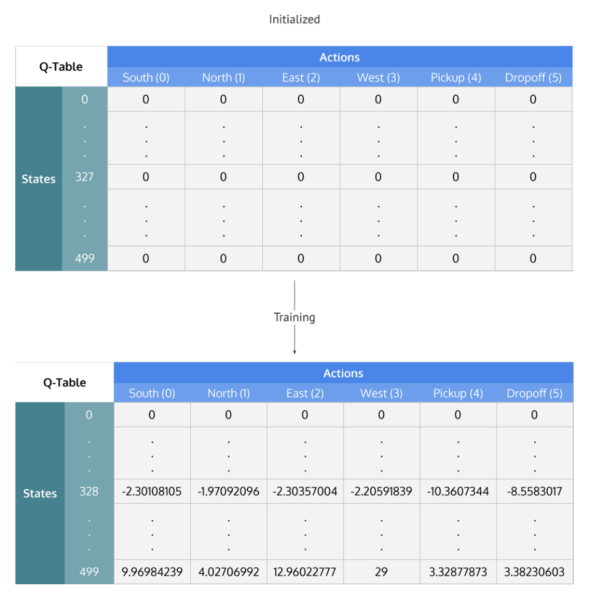

Q-Table values are initialized to zero and then updated during training to values that optimize the agent's traversal through the environment for maximum rewards

**Summing up the Q-Learning Process**

Breaking it down into steps, we get

* Initialize the Q-table by all zeros.
* Start exploring actions: For each state, select any one among all possible actions for the current state (S).
* Travel to the next state (S') as a result of that action (a).
* For all possible actions from the state (S') select the one with the highest Q-value.
* Update Q-table values using the equation.
* Set the next state as the current state.
* If goal state is reached, then end and repeat the process.

Exploiting learned values

After enough random exploration of actions, the Q-values tend to converge serving our agent as an action-value function which it can exploit to pick the most optimal action from a given state.

There's a tradeoff between exploration (choosing a random action) and exploitation (choosing actions based on already learned Q-values). We want to prevent the action from always taking the same route, and possibly overfitting, so we'll be introducing another parameter called ϵϵ "epsilon" to cater to this during training.

Instead of just selecting the best learned Q-value action, we'll sometimes favor exploring the action space further. Lower epsilon value results in episodes with more penalties (on average) which is obvious because we are exploring and making random decisions.

**Implementing Q-learning in python**

**Training the Agent**

First, we'll initialize the Q-table to a 500×6500×6 matrix of zeros:

import numpy as np

q_table = np.zeros([env.observation_space.n, env.action_space.n])

We can now create the training algorithm that will update this Q-table as the agent explores the environment over thousands of episodes.

In the first part of while not done, we decide whether to pick a random action or to exploit the already computed Q-values. This is done simply by using the epsilon value and comparing it to the random.uniform(0, 1) function, which returns an arbitrary number between 0 and 1.

We execute the chosen action in the environment to obtain the next_state and the reward from performing the action. After that, we calculate the maximum Q-value for the actions corresponding to the next_state, and with that, we can easily update our Q-value to the new_q_value:

%%time

"""Training the agent"""

import random

from IPython.display import clear_output

# Hyperparameters

alpha = 0.1

gamma = 0.6

epsilon = 0.1

# For plotting metrics

all_epochs = []

all_penalties = []

for i in range(1, 100001):

    state = env.reset()

    epochs, penalties, reward, = 0, 0, 0

    done = False

    while not done:

        if random.uniform(0, 1) < epsilon:

            action = env.action_space.sample() # Explore action space

        else:

            action = np.argmax(q_table[state]) # Exploit learned values

        next_state, reward, done, info = env.step(action)

        old_value = q_table[state, action]

        next_max = np.max(q_table[next_state])

        new_value = (1 - alpha) * old_value + alpha * (reward + gamma * next_max)

        q_table[state, action] = new_value

        if reward == -10:

            penalties += 1

        state = next_state

        epochs += 1

    if i % 100 == 0:

        clear_output(wait=True)

        print(f"Episode: {i}")

print("Training finished.\n")

**OUT:**

Episode: 100000

Training finished.

Wall time: 30.6 s

Now that the Q-table has been established over 100,000 episodes, let's see what the Q-values are at our illustration's state:

q_table[328]

**OUT:**

array([ -2.30108105,  -1.97092096,  -2.30357004,  -2.20591839,

       -10.3607344 ,  -8.5583017 ])

The max Q-value is "north" (-1.971), so it looks like Q-learning has effectively learned the best action to take in our illustration's state!

**Evaluating the agent**

Let's evaluate the performance of our agent. We don't need to explore actions any further, so now the next action is always selected using the best Q-value:

"""Evaluate agent's performance after Q-learning"""

total_epochs, total_penalties = 0, 0

episodes = 100

for _ in range(episodes):

    state = env.reset()

    epochs, penalties, reward = 0, 0, 0

    done = False

    while not done:

        action = np.argmax(q_table[state])

        state, reward, done, info = env.step(action)

        if reward == -10:

            penalties += 1

        epochs += 1

    total_penalties += penalties

    total_epochs += epochs

print(f"Results after {episodes} episodes:")

print(f"Average timesteps per episode: {total_epochs / episodes}")

print(f"Average penalties per episode: {total_penalties / episodes}")

**OUT:**

Results after 100 episodes:

Average timesteps per episode: 12.3

Average penalties per episode: 0.0

We can see from the evaluation, the agent's performance improved significantly and it incurred no penalties, which means it performed the correct pickup/dropoff actions with 100 different passengers.

**Comparing our Q-learning agent to no Reinforcement Learning**

With Q-learning agent commits errors initially during exploration but once it has explored enough (seen most of the states), it can act wisely maximizing the rewards making smart moves. Let's see how much better our Q-learning solution is when compared to the agent making just random moves.

We evaluate our agents according to the following metrics,

* **Average number of penalties per episode:** The smaller the number, the better the performance of our agent. Ideally, we would like this metric to be zero or very close to zero.
* **Average number of timesteps per trip:** We want a small number of timesteps per episode as well since we want our agent to take minimum steps(i.e. the shortest path) to reach the destination.
* **Average rewards per move:** The larger the reward means the agent is doing the right thing. That's why deciding rewards is a crucial part of Reinforcement Learning. In our case, as both timesteps and penalties are negatively rewarded, a higher average reward would mean that the agent reaches the destination as fast as possible with the least penalties"

|  |  |  |
| --- | --- | --- |
| **Measure** | **Random agent's performance** | **Q-learning agent's performance** |
| Average rewards per move | -3.9012092102214075 | 0.6962843295638126 |
| Average number of penalties per episode | 920.45 | 0.0 |
| Average number of timesteps per trip | 2848.14 | 12.38 |

These metrics were computed over 100 episodes. And as the results show, our Q-learning agent nailed it!

**Hyperparameters and optimizations**

The values of `alpha`, `gamma`, and `epsilon` were mostly based on intuition and some "hit and trial", but there are better ways to come up with good values.

Ideally, all three should decrease over time because as the agent continues to learn, it actually builds up more resilient priors;

* αα: (the learning rate) should decrease as you continue to gain a larger and larger knowledge base.
* γγ: as you get closer and closer to the deadline, your preference for near-term reward should increase, as you won't be around long enough to get the long-term reward, which means your gamma should decrease.
* ϵϵ: as we develop our strategy, we have less need of exploration and more exploitation to get more utility from our policy, so as trials increase, epsilon should decrease.

Tuning the hyperparameters

A simple way to programmatically come up with the best set of values of the hyperparameter is to create a comprehensive search function (similar to [grid search](https://en.wikipedia.org/wiki/Hyperparameter_optimization#Grid_search)) that selects the parameters that would result in best reward/time_steps ratio. The reason for reward/time_steps is that we want to choose parameters which enable us to get the maximum reward as fast as possible. We may want to track the number of penalties corresponding to the hyperparameter value combination as well because this can also be a deciding factor (we don't want our smart agent to violate rules at the cost of reaching faster). A more fancy way to get the right combination of hyperparameter values would be to use Genetic Algorithms.

**Conclusion and What's Ahead**

Alright! We began with understanding Reinforcement Learning with the help of real-world analogies. We then dived into the basics of Reinforcement Learning and framed a Self-driving cab as a Reinforcement Learning problem. We then used OpenAI's Gym in python to provide us with a related environment, where we can develop our agent and evaluate it. Then we observed how terrible our agent was without using any algorithm to play the game, so we went ahead to implement the Q-learning algorithm from scratch. The agent's performance improved significantly after Q-learning. Finally, we discussed better approaches for deciding the hyperparameters for our algorithm.

Q-learning is one of the easiest Reinforcement Learning algorithms. The problem with Q-earning however is, once the number of states in the environment are very high, it becomes difficult to implement them with Q table as the size would become very, very large. State of the art techniques uses Deep neural networks instead of the Q-table (Deep Reinforcement Learning). The neural network takes in state information and actions to the input layer and learns to output the right action over the time. Deep learning techniques (like Convolutional Neural Networks) are also used to interpret the pixels on the screen and extract information out of the game (like scores), and then letting the agent control the game.

We have discussed a lot about Reinforcement Learning and games. But Reinforcement learning is not just limited to games. It is used for managing stock portfolios and finances, for making humanoid robots, for manufacturing and inventory management, to develop general AI agents, which are agents that can perform multiple things with a single algorithm, like the same agent playing multiple Atari games. Open AI also has a platform called universe for measuring and training an AI's general intelligence across myriads of games, websites and other general applications.

MODULE 1

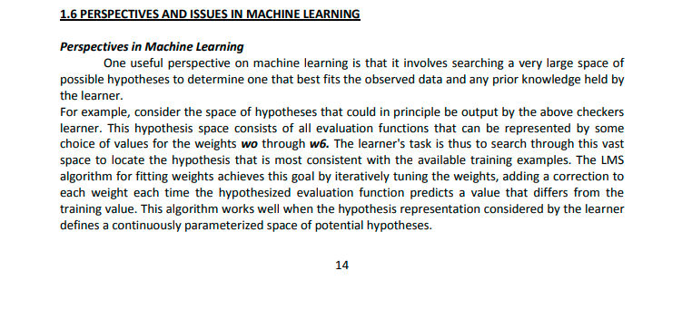

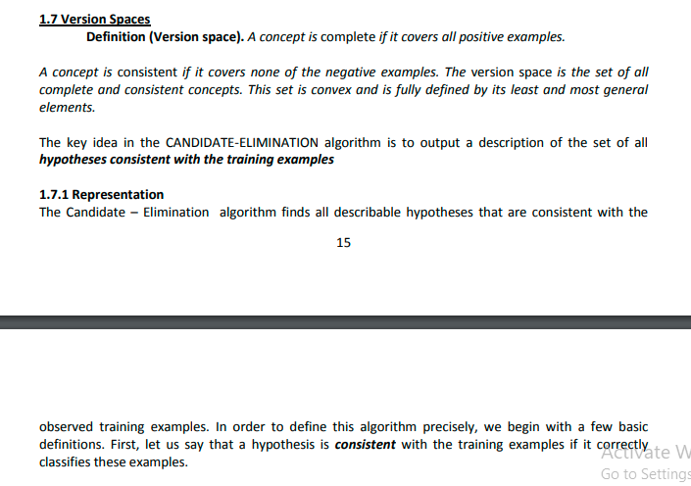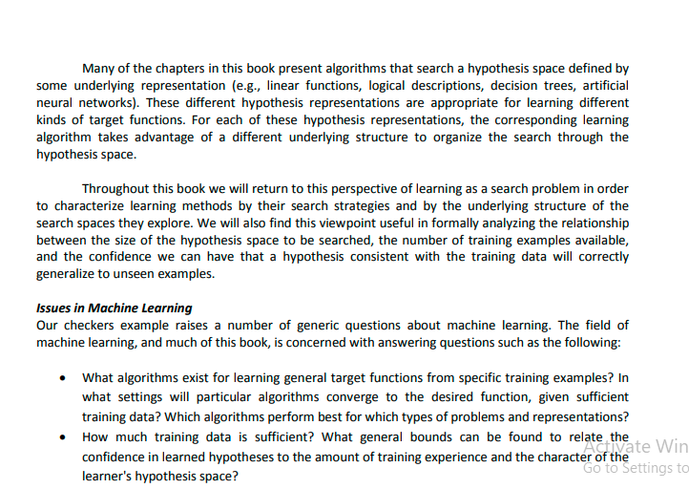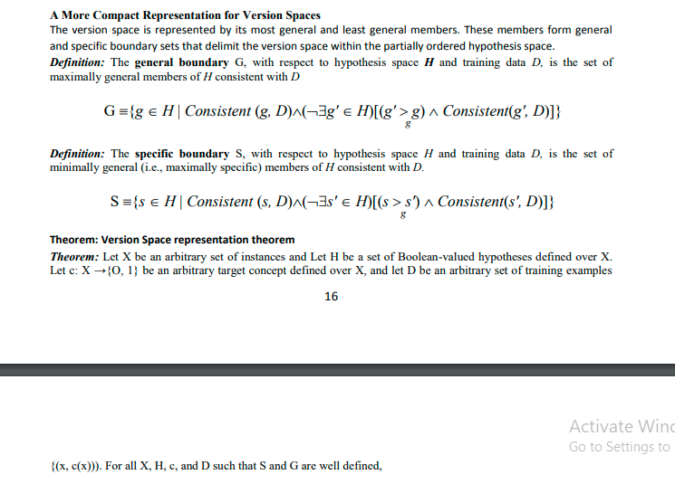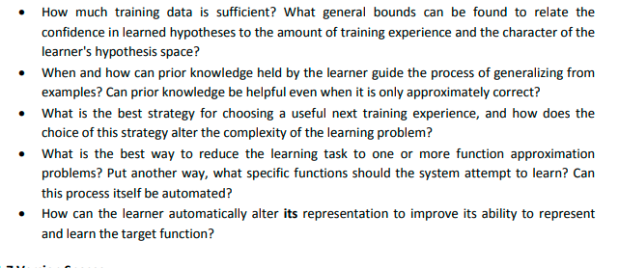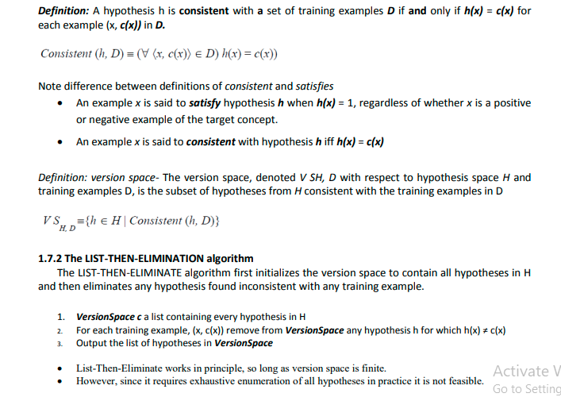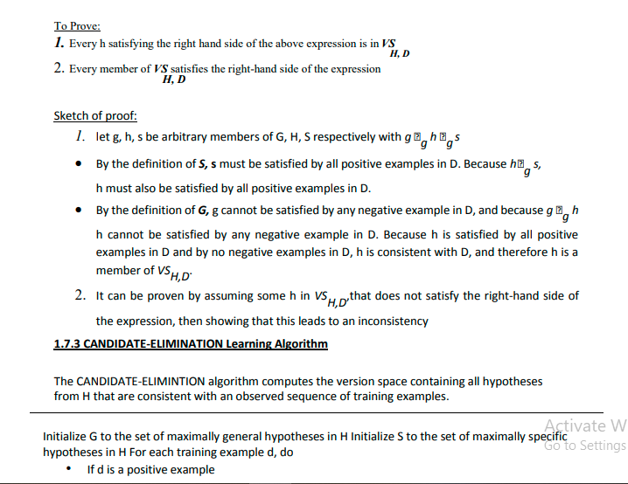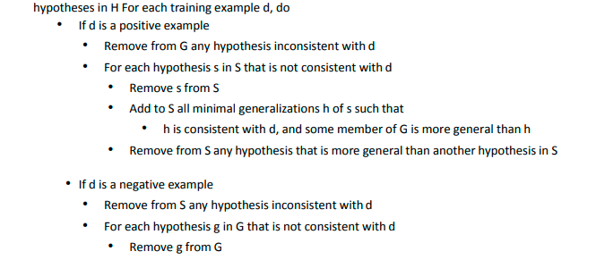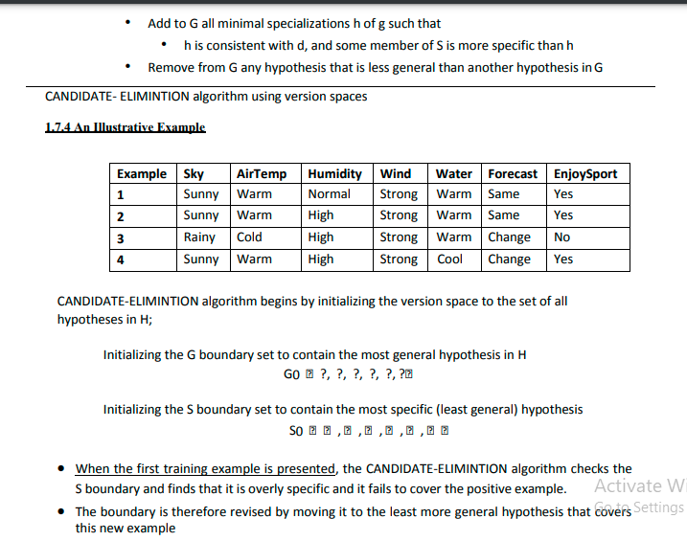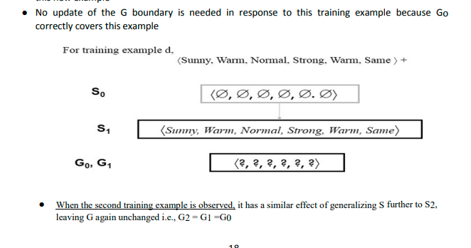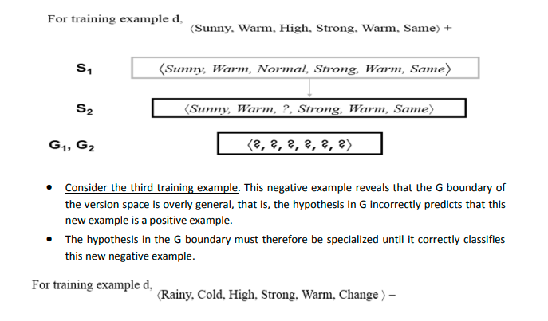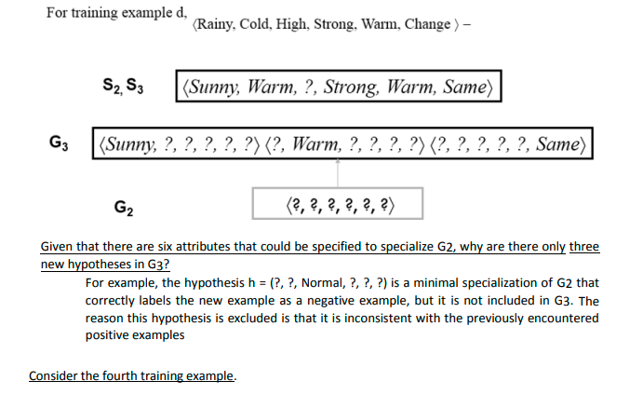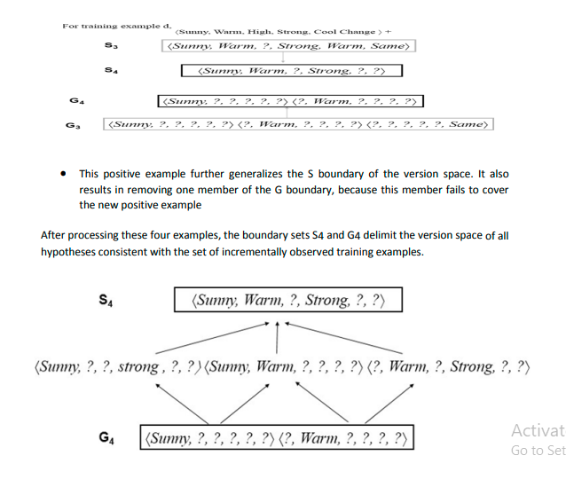

PAC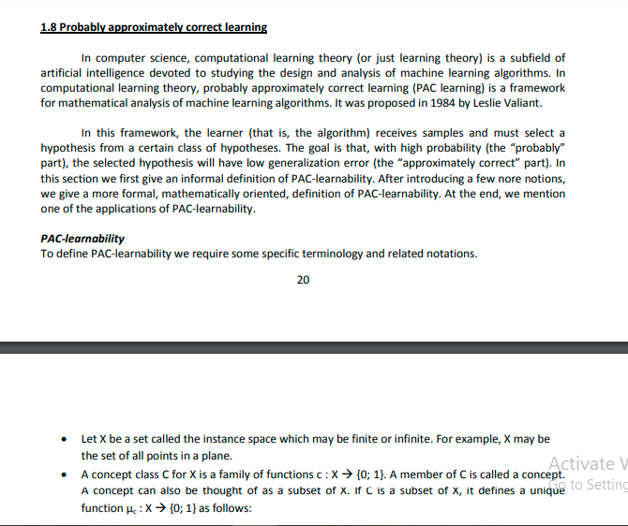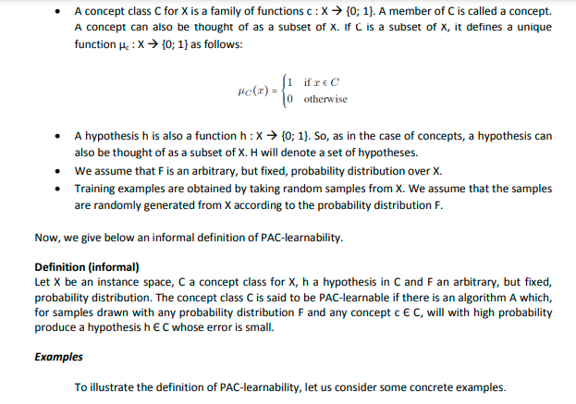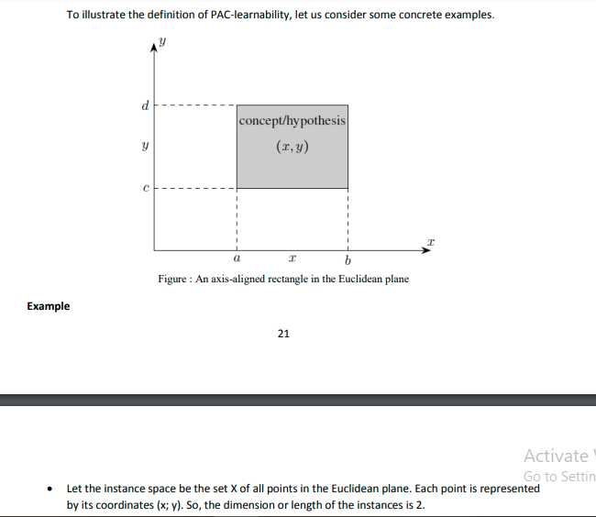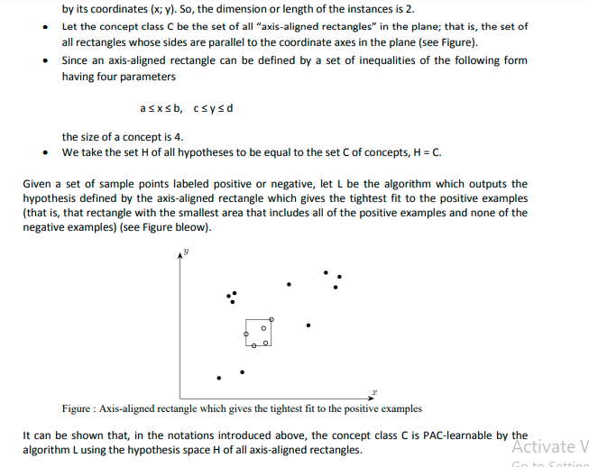

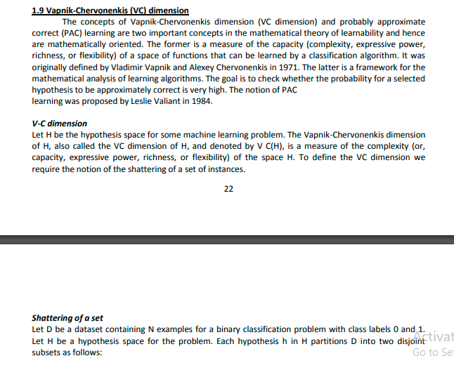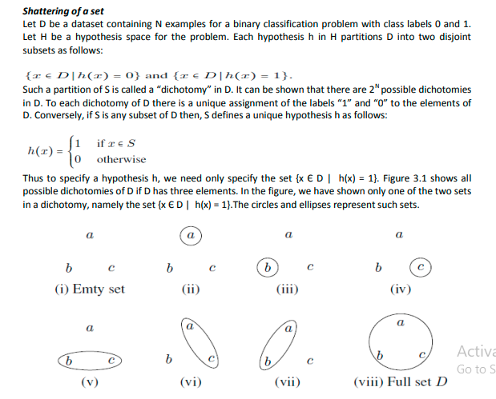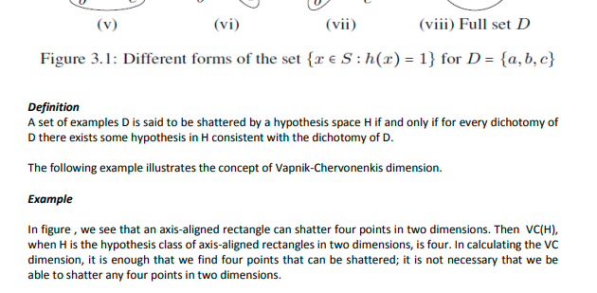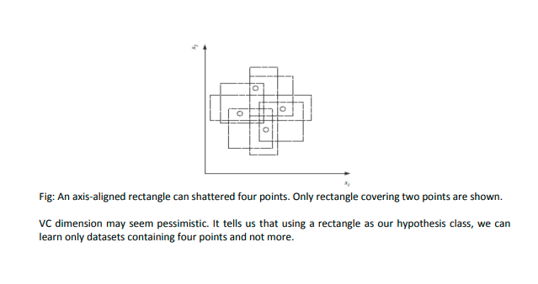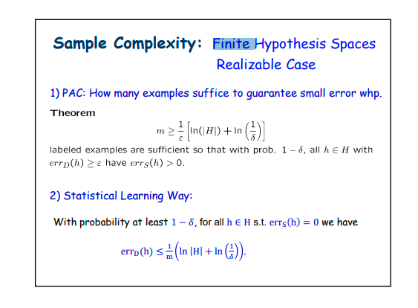To understand the difference between finite and infinite machine learning we first need to get some basics for machine learning. Most of the tools in machine learning are designed to make better use data using PAC (Probably Approximately Correct), first introduced by Professor Valiant. The PAC analyses assume that the true answer/concept is in the given hypothesis space H. A machine learning algorithm L with hypothesis space H is one that, given a training data set D, will always return a hypothesis H consistent with D if one exists, otherwise it will indicate that no such hypothesis exists. In a finite machine learning hypothesis H does not have polynomial sample complexity. If H has polynomial sample complexity it is called infinite hypothesis. 